**COMMVAULT Installation & Setup Manual**

Commvault is an enterprise-level data platform that contains modules to backup, restore, archive, replicate, and search data.

It enables to use multiple protection methods including backup and archive, snapshot management, replication, and content indexing for eDiscovery, and conducts efficient storage management using deduplication for disk and tape.

It supports a variety of sources such File Systems, Databases, Virtual Servers, Cloud Apps, etc.

**System Requirement for Commvault Installation**:

* Commserve (Commvault’s server component) can only be configured on a machine with Windows OS (Microsoft Windows Server 2019, 2016, 2012, 2012 R2, Editions). Ensure your VM/local system is window OS based.
* The VM/local system must contain about 80GB of local storage, 200GB for Disk library storage, and 40GB for Deduplication database (DDB).

**Minimum Configuration:**

* System Requirement needs to be satisfied.
* Storage Pool needs to be configured. The method of configuration has been mentioned in “Steps for Commvault Installation” section.

**Steps for Commvault Installation:**

1. Navigate to<https://www.commvault.com/trials/commvault-data-platform> and fill the “download the trial” form to create an account and experience a trial of commvault & its features. Note down your username & password of your commvault trial account.

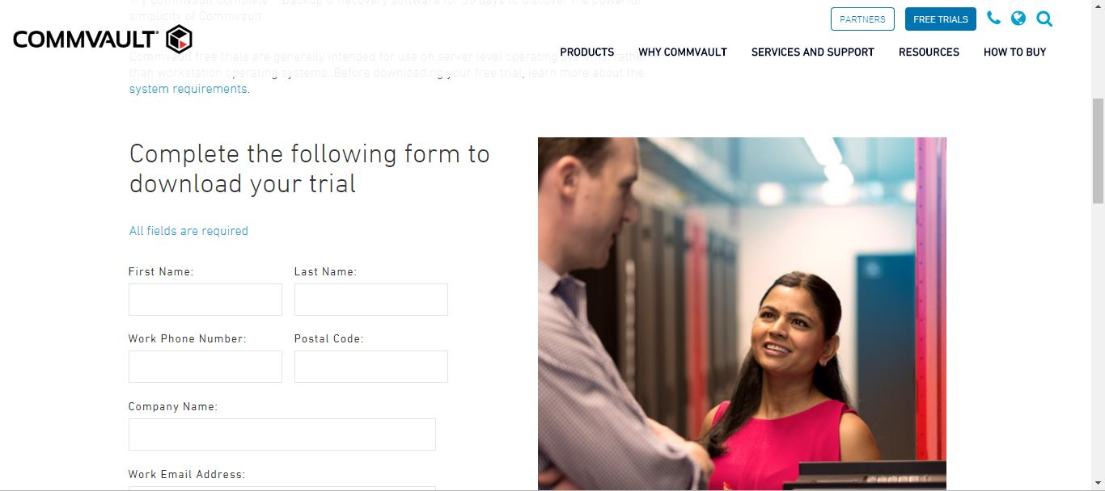

1. Navigate to the VM/local system where you need to install and configure commvault software.
2. Open the web console of commvault in your machine, by using the following link [https://cloud.commvault.com/webconsole/login/index.jsp#](https://cloud.commvault.com/webconsole/login/index.jsp)

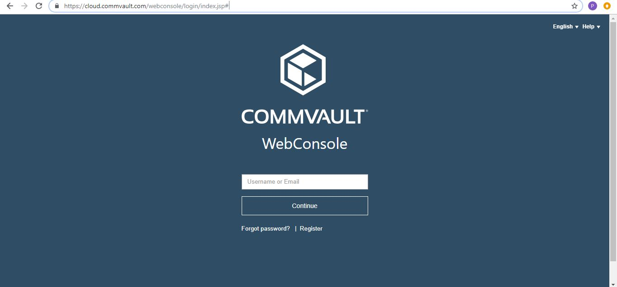

1. Enter your username/mailID & password to log in. Navigate to Download Center & select the commvault package to be installed whose name starts with "Commvault Express"V11 SP14/15.

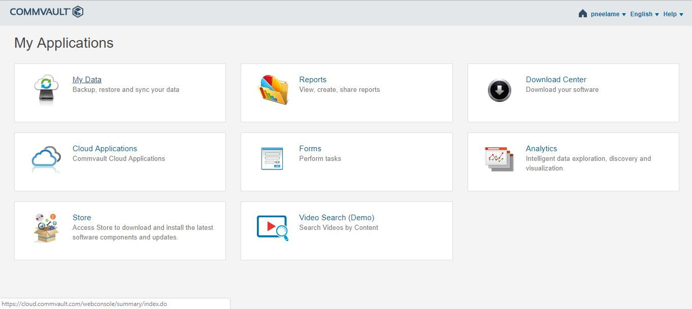

1. Select the required Commvault Package (latest Package preferred V11 SP15 Commvault Express) & hit Download.

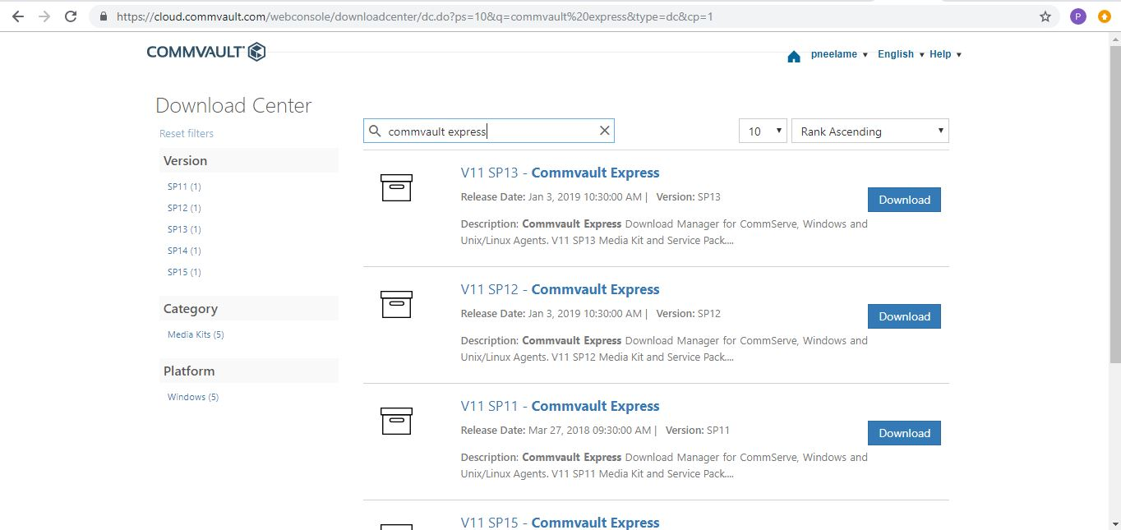

1. Navigate to the downloaded package & right click & click on "Run as administrator" option.

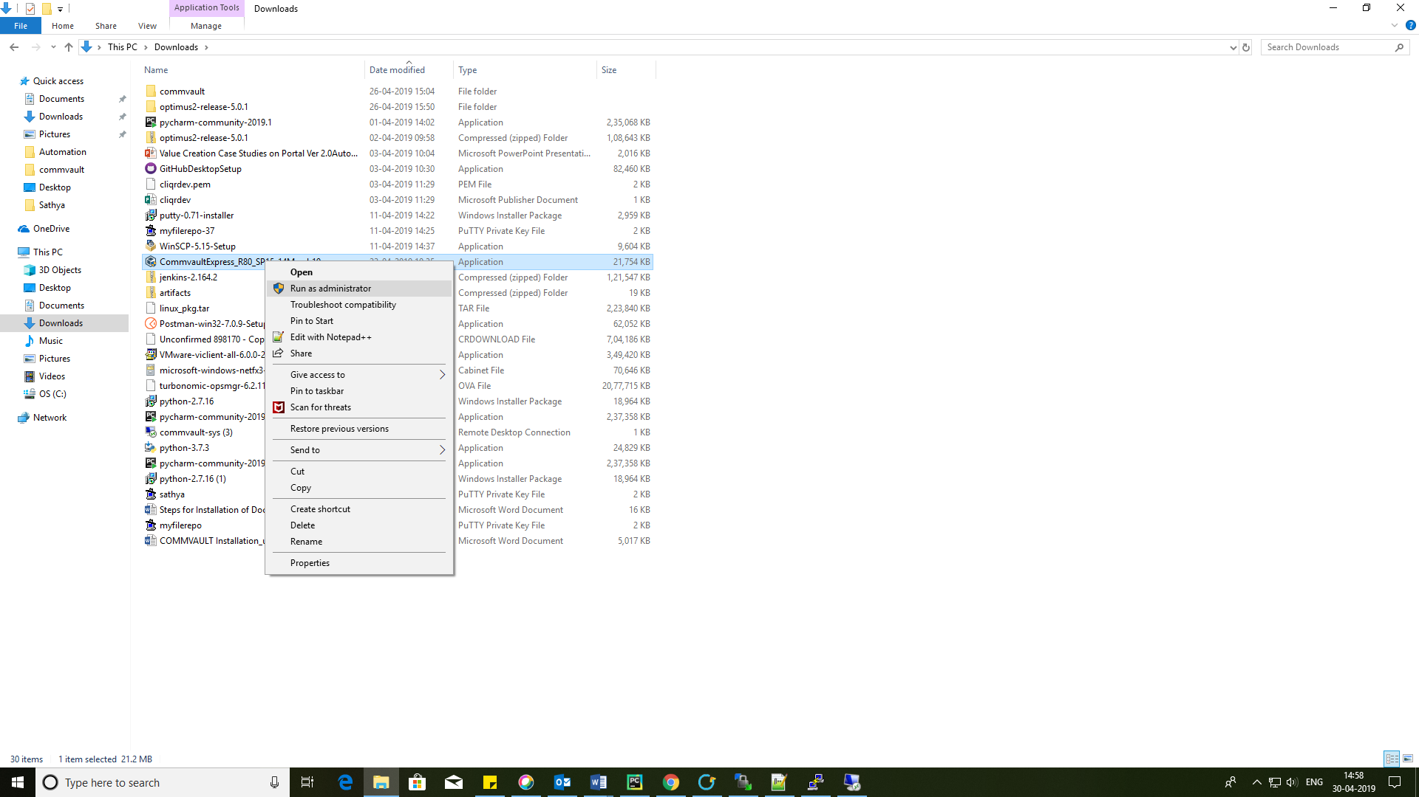

1. Commvault installation dialog is opened.

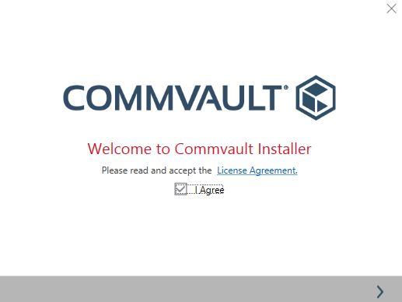

1. Select "Install the packages on this computer". Commvault installation may take a few minutes.

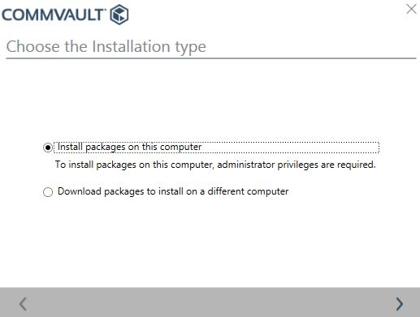

1. In the process of installation, admin console, web console & commcell console will be installed onto your machine. Once installation is done, you will be presented with URLs for admin console access and web console access.

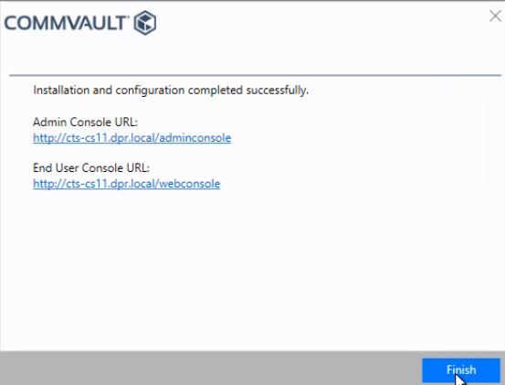

1. Note down the links for accessing admin console and web console. Open the admin console URL, and as the first step in setting up, register the product, using your commvault account credentials and activation code that was sent to you while creating your account.

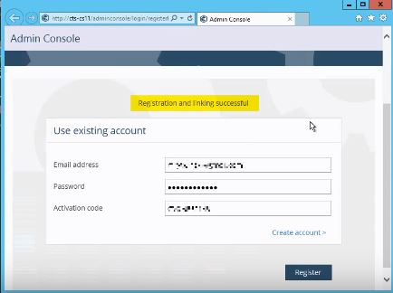

1. After registering your account, you will be asked to login into the admin console. Provide your commvault account credentials to login into the admin console.
2. If registering the product step is completed, you will be asked to configure your SMTP mail details. Complete it.

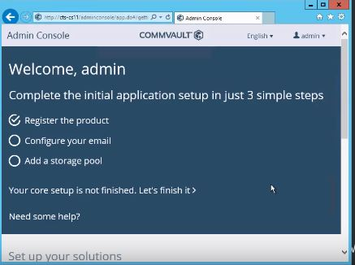

1. Next, configure a storage pool. Prepare a storage of 200GB for disk library and 40GB for Deduplication database (DDB) locally/remotely. Configure a storage pool, by adding the local path/network path of storage you have just prepared, for the disk library and DDB partition path.

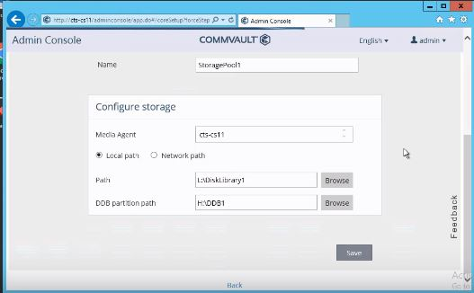

1. You will be presented with the dashboard of Admin console.

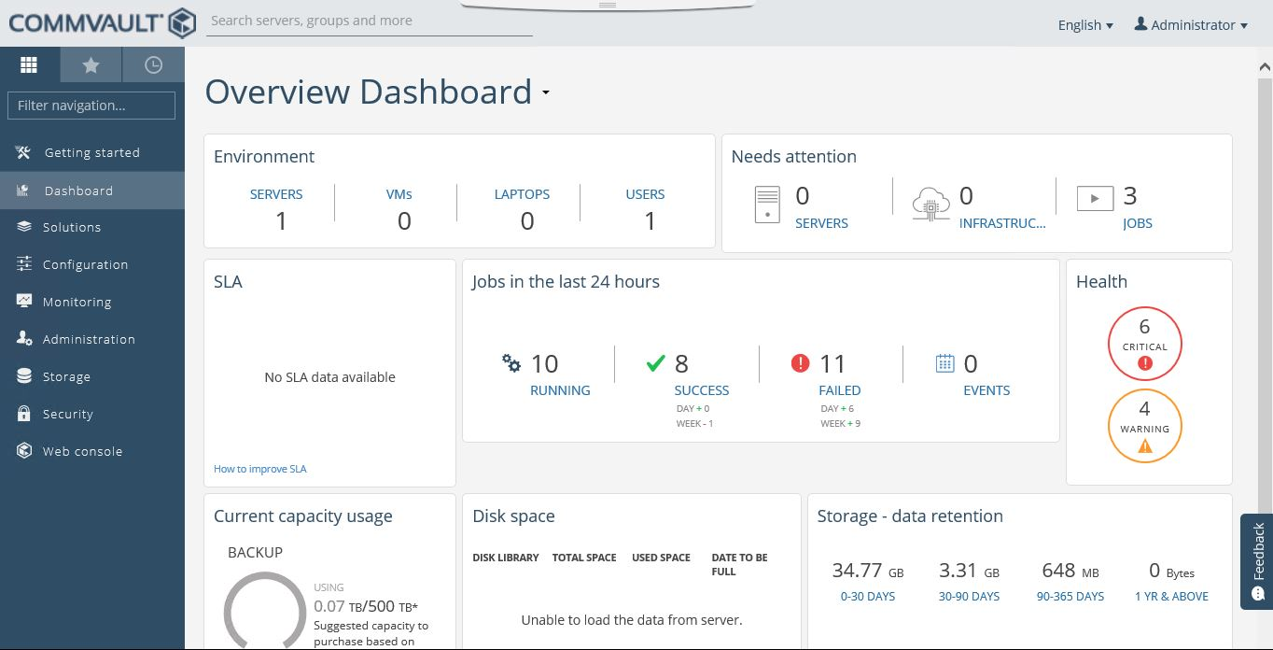

**Backing up Files (using File System Agent)**

1. To perform backup & restore functions in a specific client, navigate to “Administration”-> Servers, from the menu on the left side of the screen.

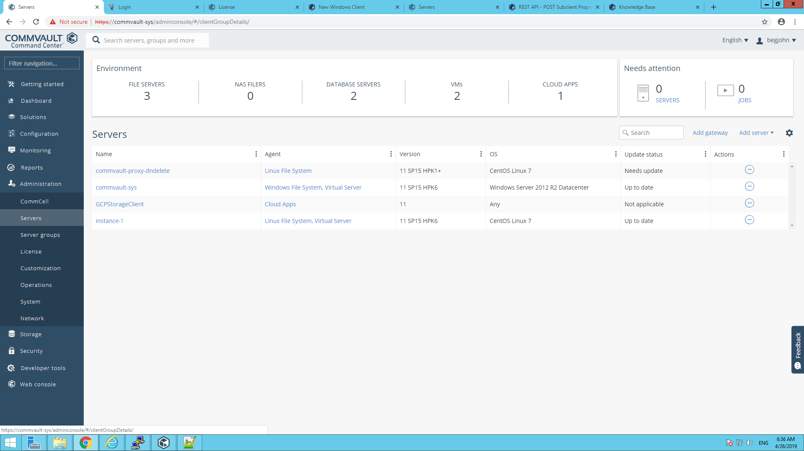

1. Under servers, the local clients and already registered remote clients will be available. Click on a client having agent (either Windows File System or Linux File System).
2. The list of agents that is already present on the client will appear.

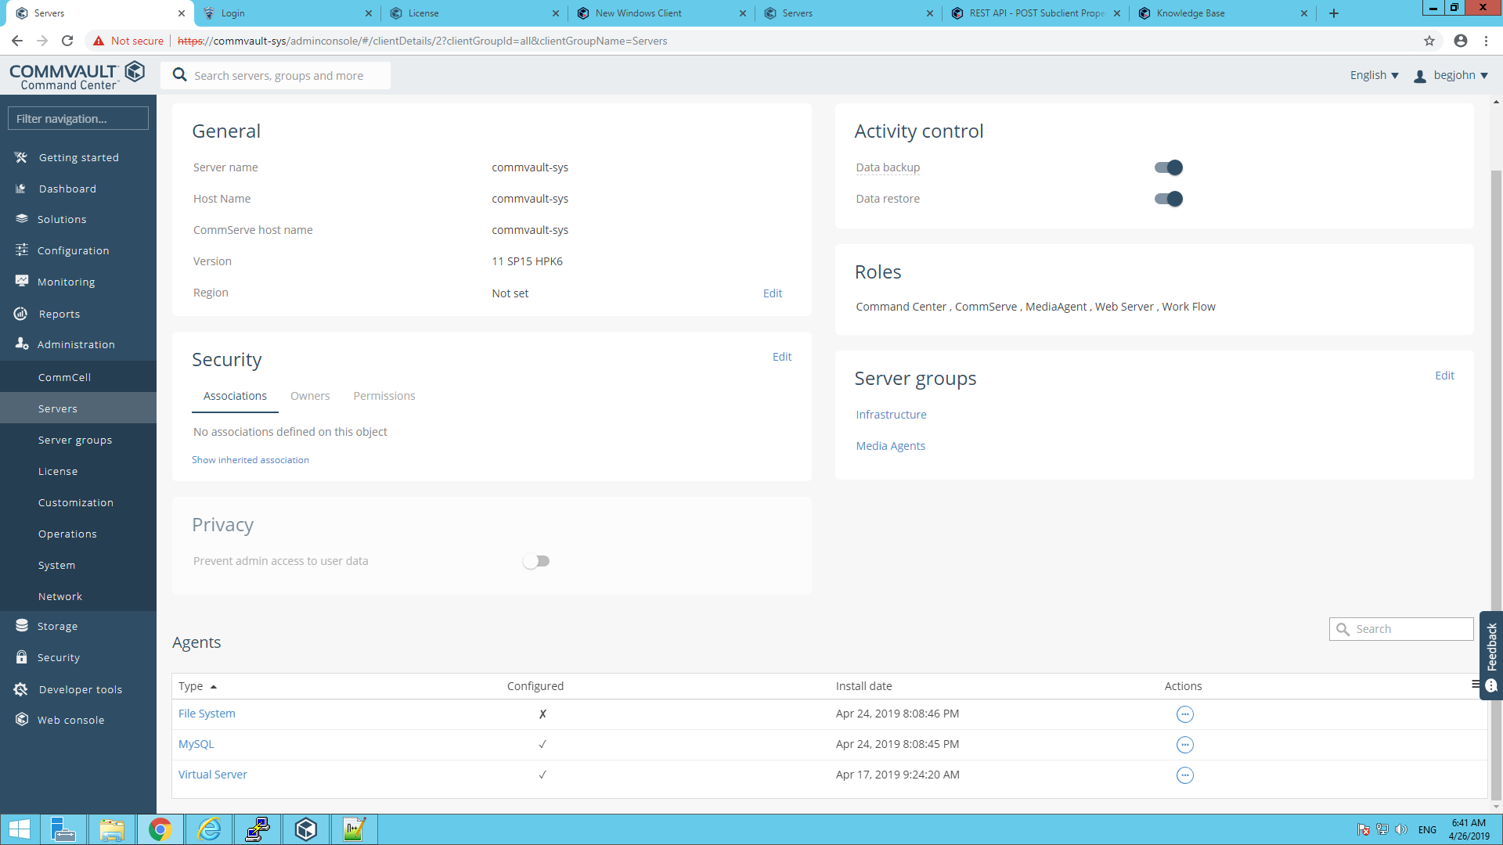

1. Under “Agents”, Choose File System. Backup sets available under the agent will appear.

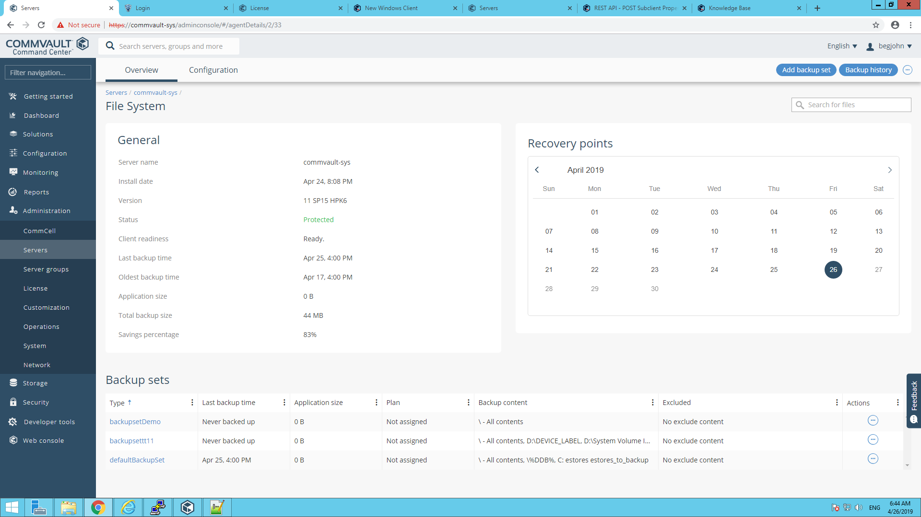

1. Navigate to the “Configuration” tab. Click on the “Add backup set” option present on the top right corner. Fill in the name of the backup set & the plan to be used for the backup set.

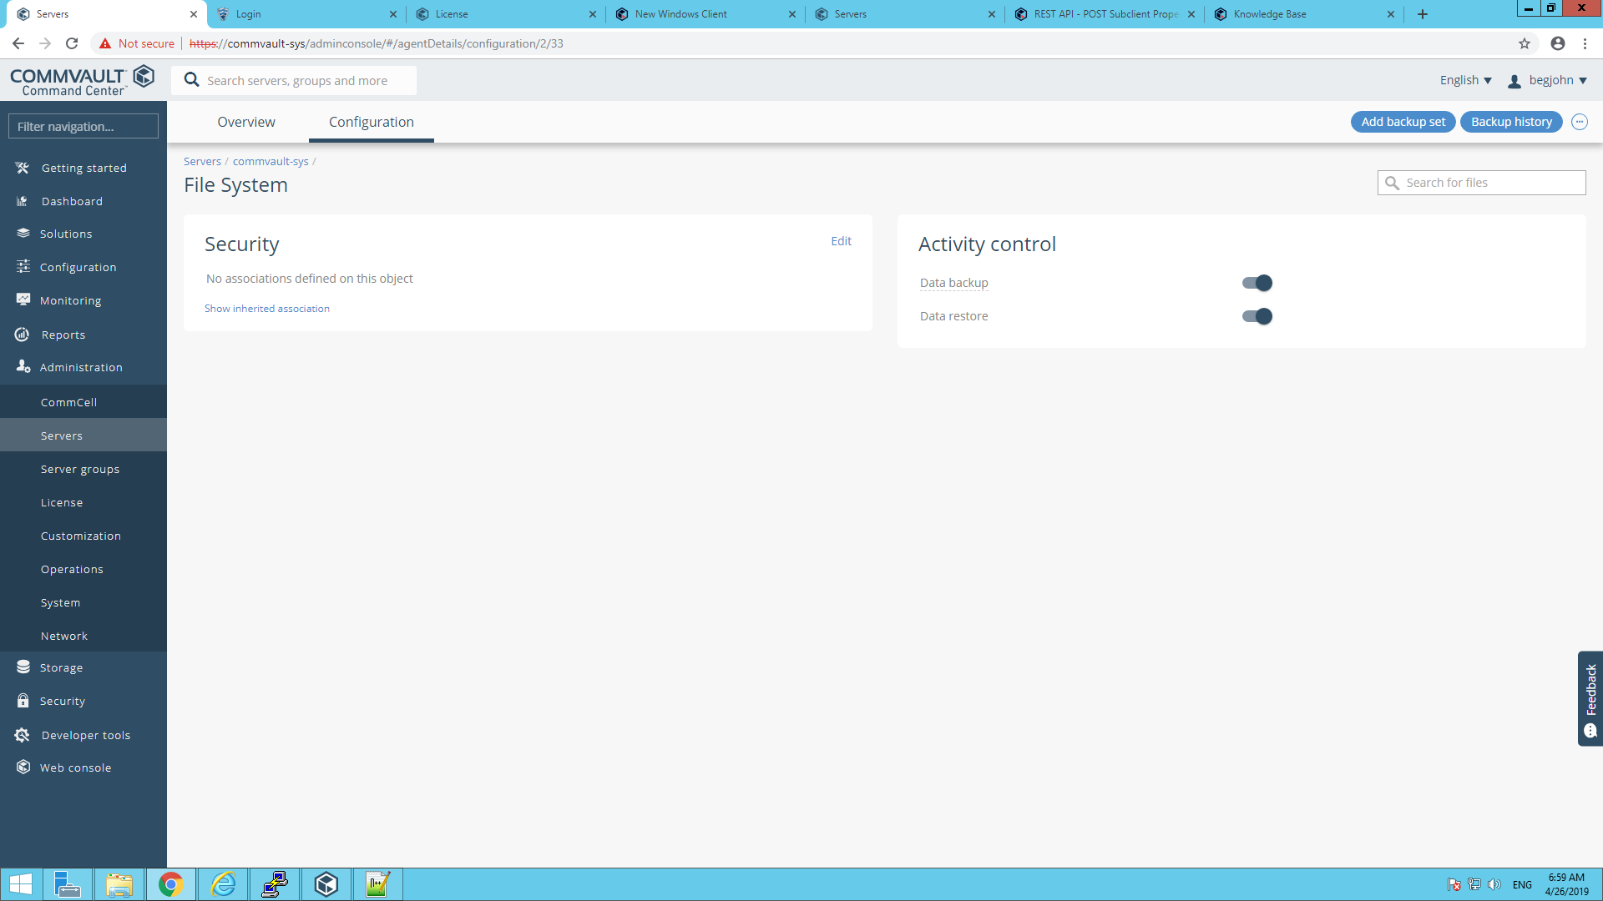

1. Select the newly created backup set. On the top right corner of the screen, you will find “Add subclient”. Click on it to add a subclient.

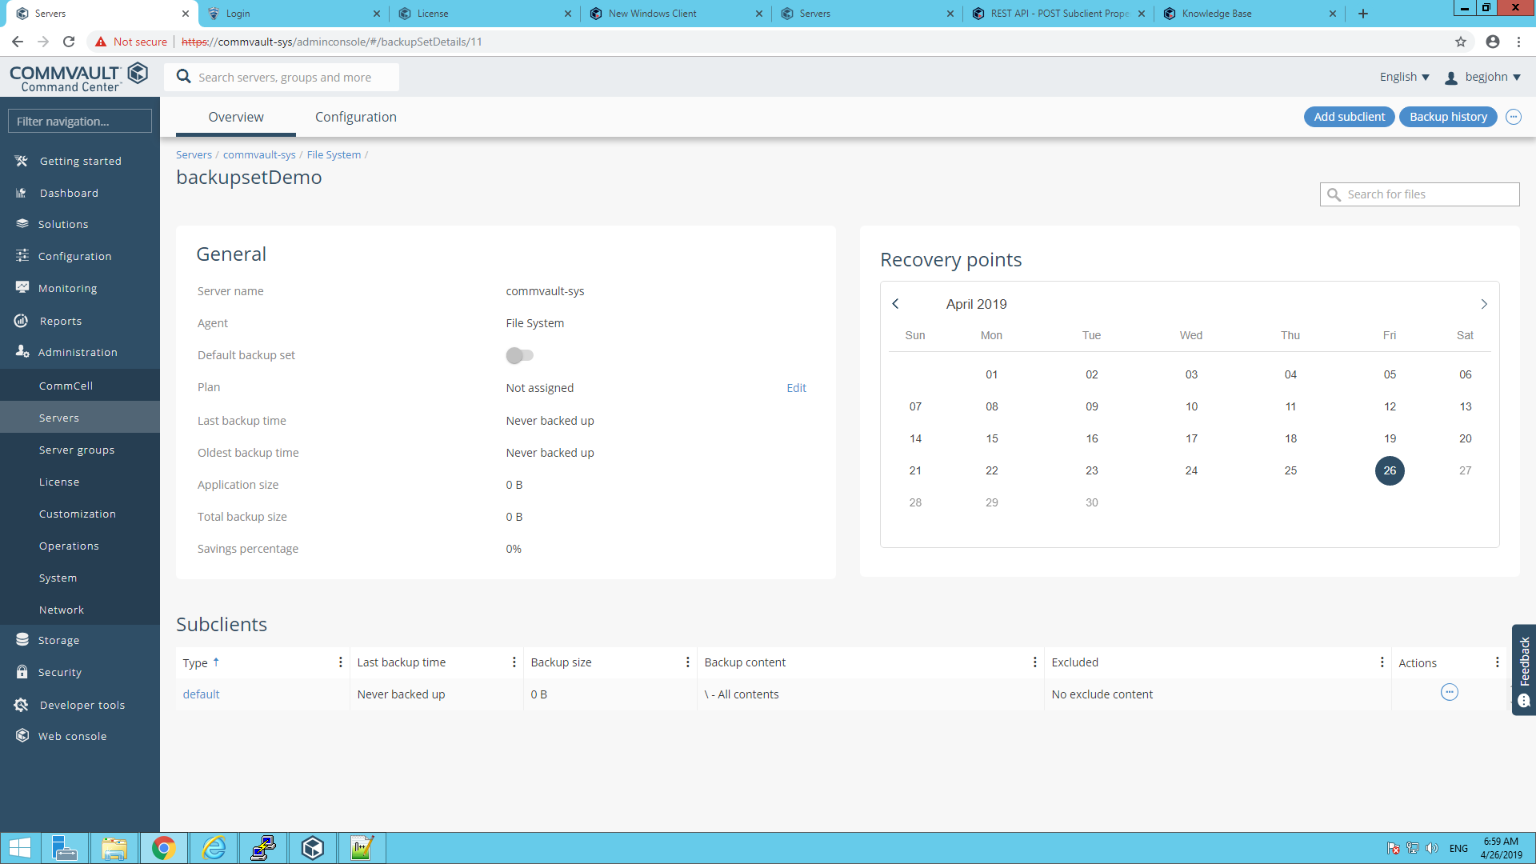

1. Fill in the form to add a new subclient.

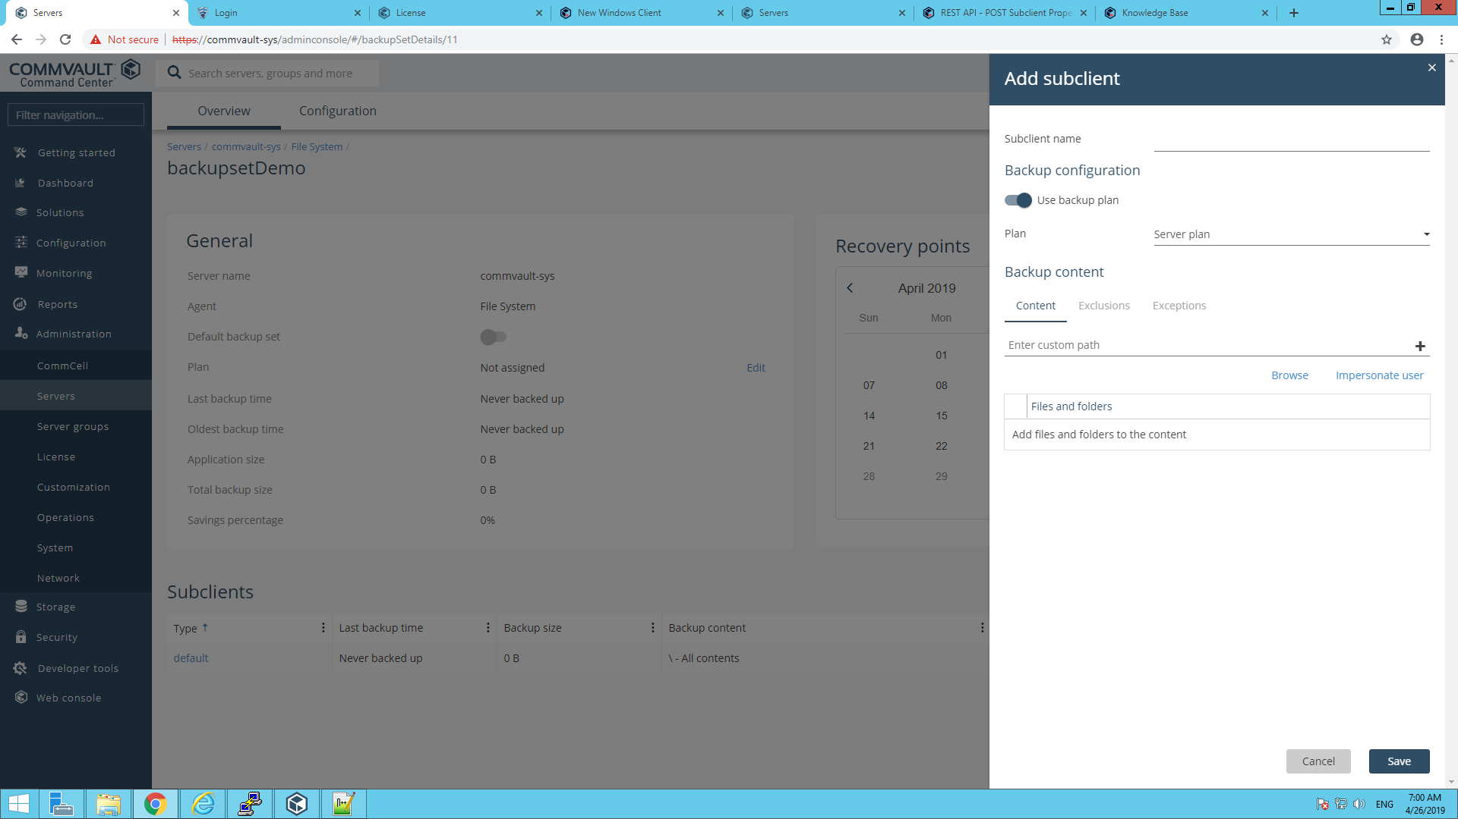

1. The subclient contents can be backed, by clicking on option “backup” listed by clicking on the … button in the created subclient.

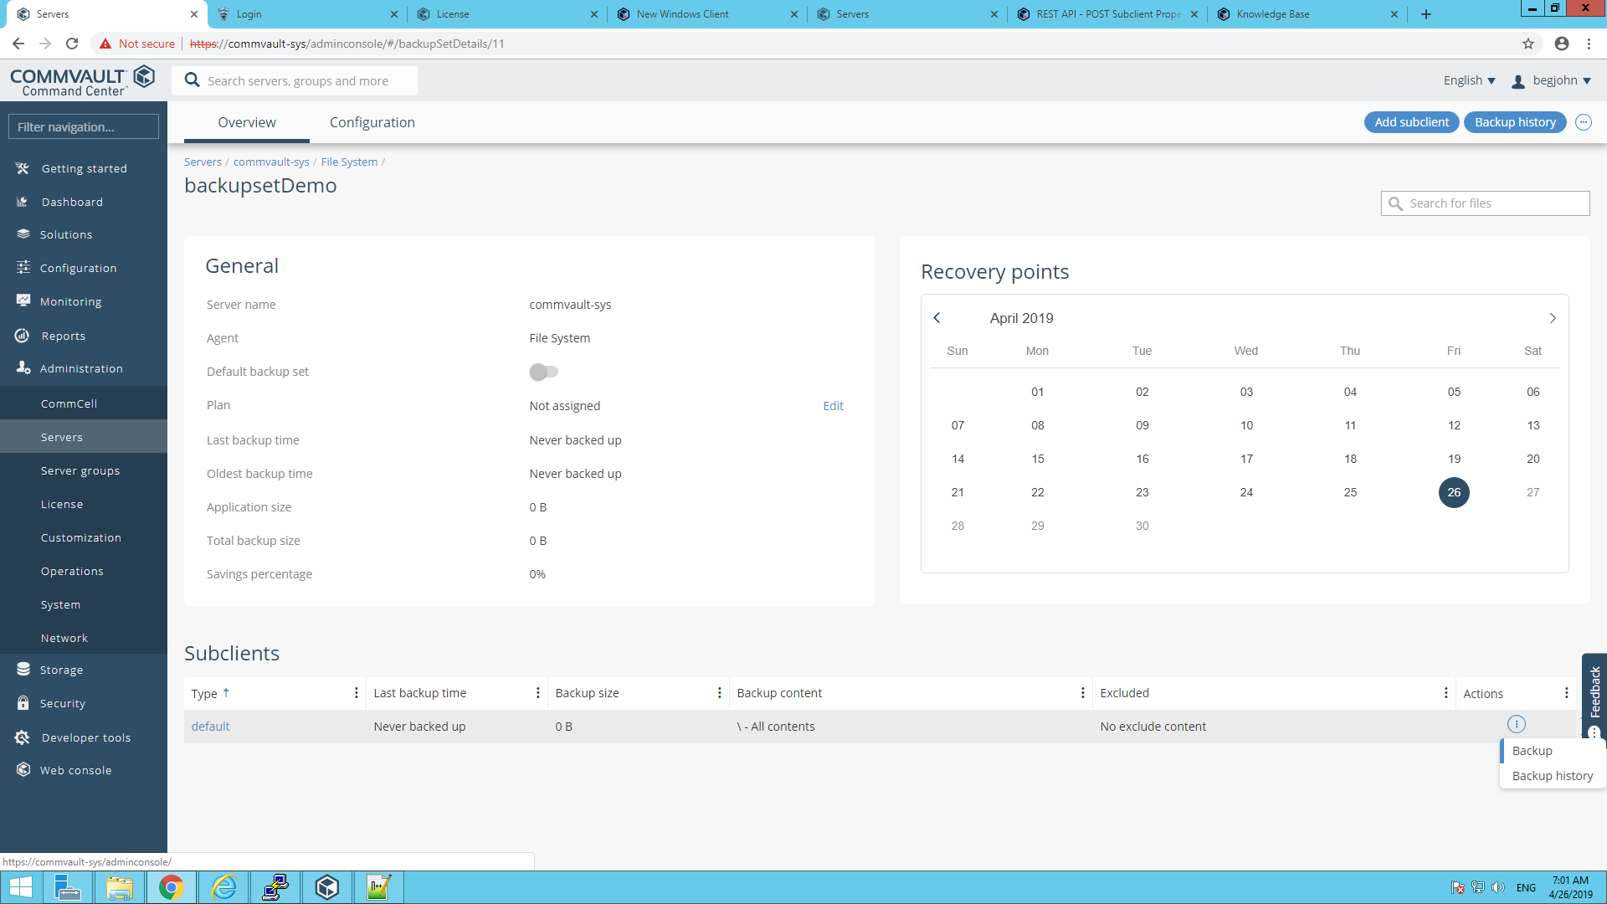

1. Select the backup level and click “OK”.

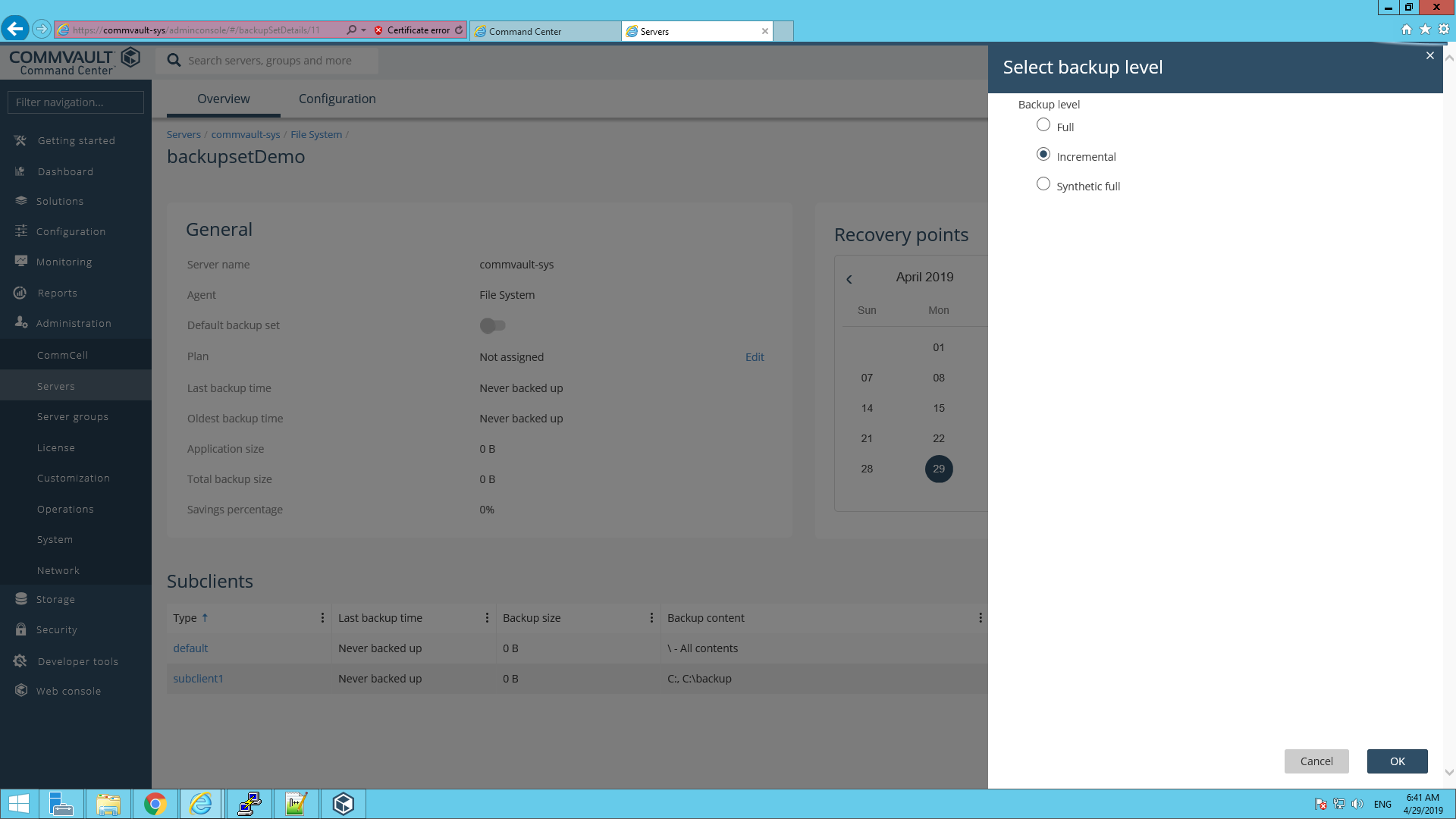

1. On the top right corner of the screen, you will find “Backup history”. Click on it to view the job history.

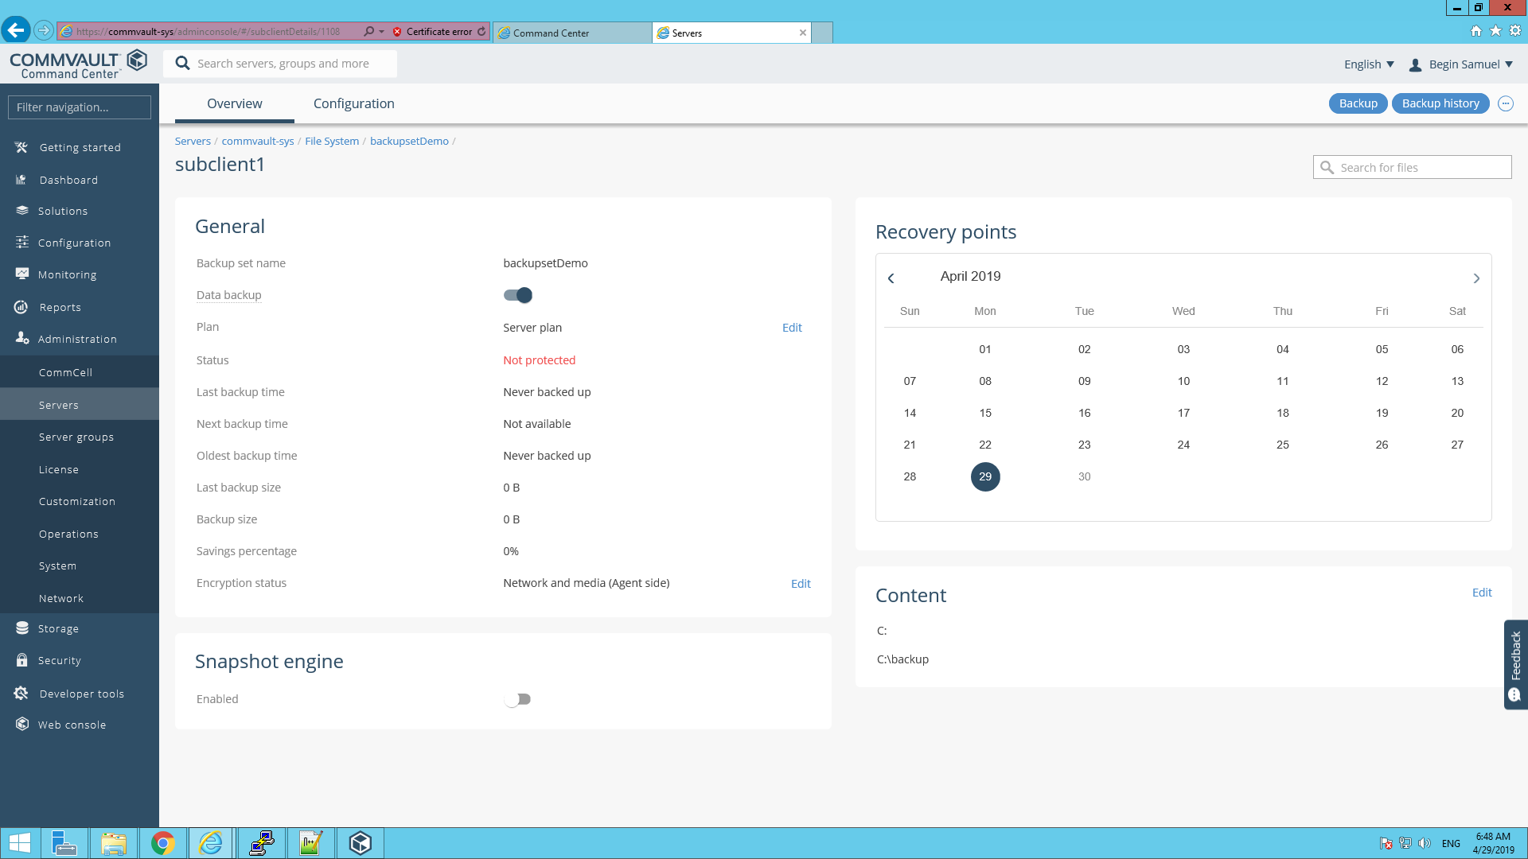

1. Once the backup is completed, the job id will be available in the job history. Select the job id.

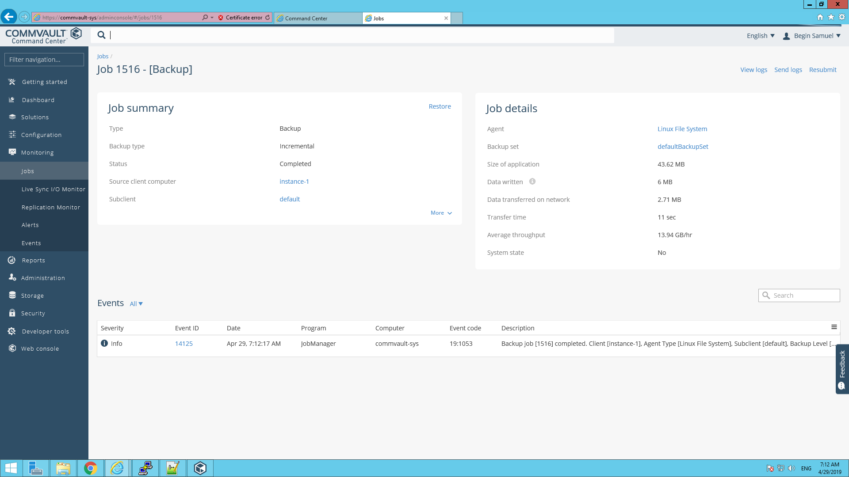

1. From the job summary, select “Restore”. Then select the content and click “Restore”.

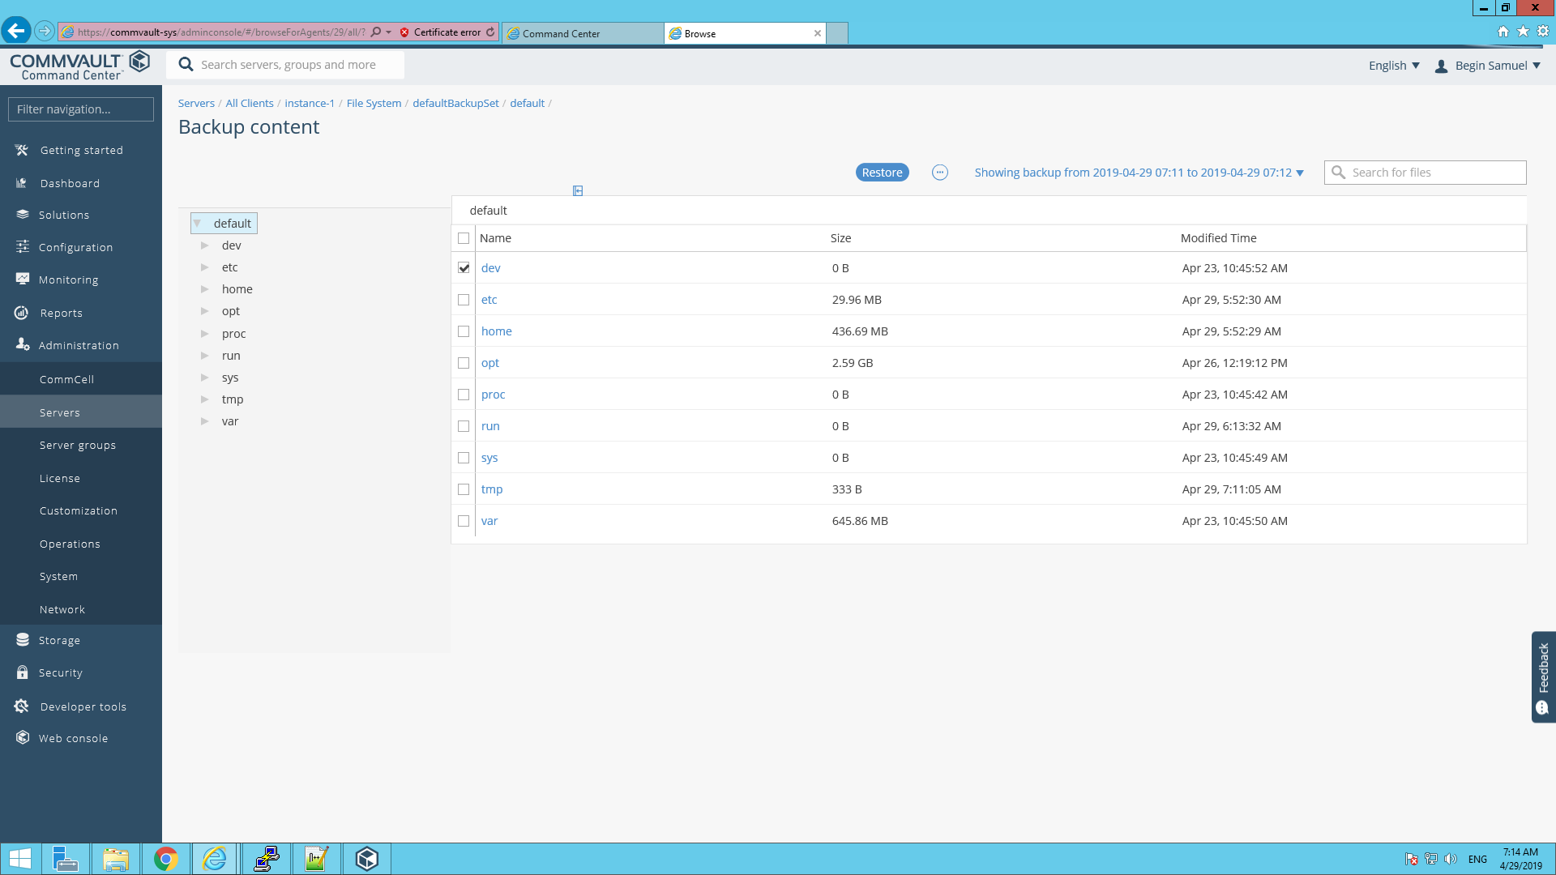

1. Select the Restore option and fill the required fields. Click “Submit”.

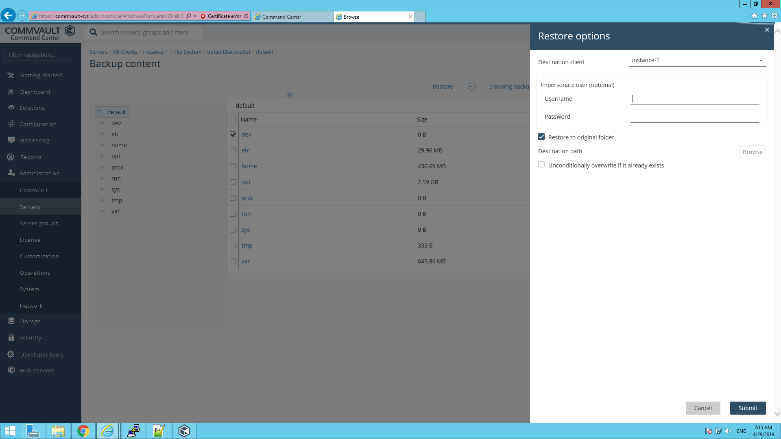

1. Navigate to “Monitoring->Jobs” to view the status of restore. Once the restore is completed, the job id will be available in the job history. Select the job id to view the log and job details.

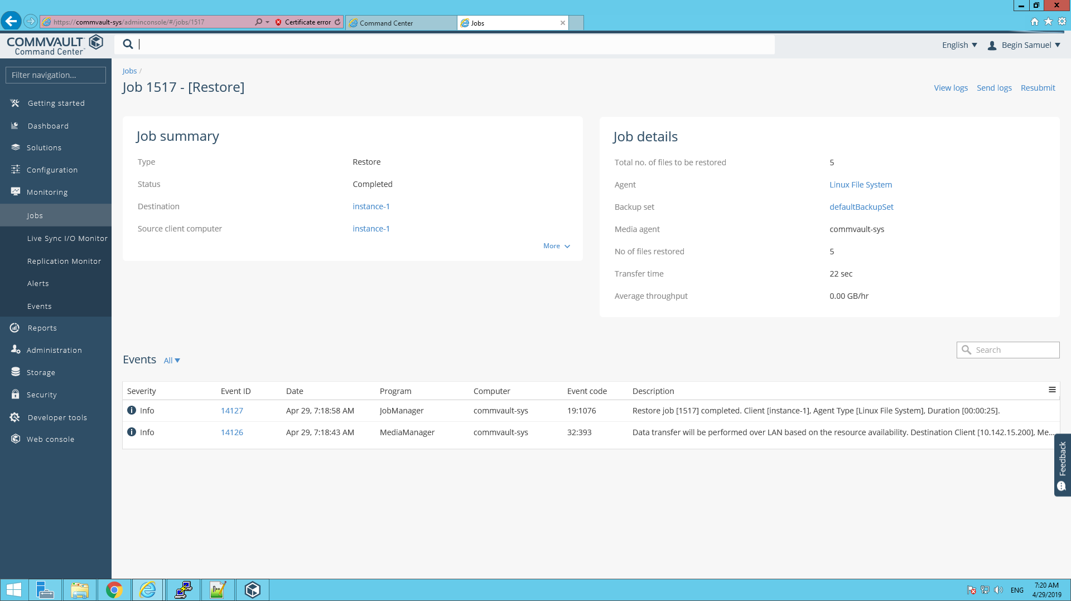

**Backing up Database ( Using MySQL Agent):**

1. To perform backup & restore functions in a specific client, navigate to “Administration”-> Servers, from the menu on the left side of the screen.

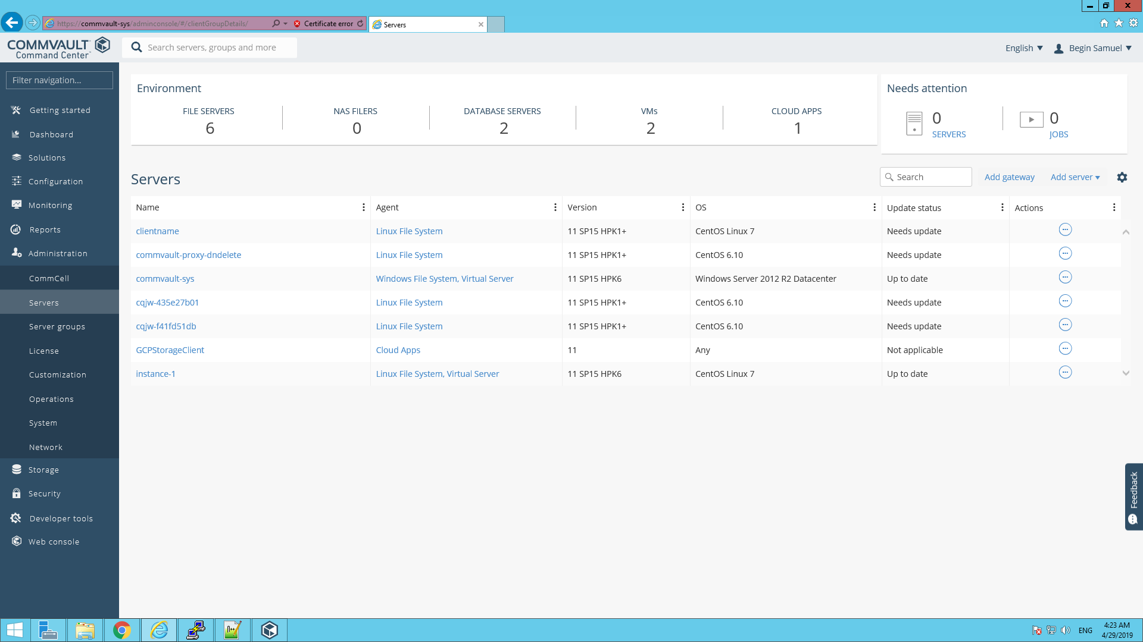

1. Under servers, the local clients and already registered remote clients will be available. Click on a client having agent (MySQL).
2. The list of agents that is already present on the client will appear.

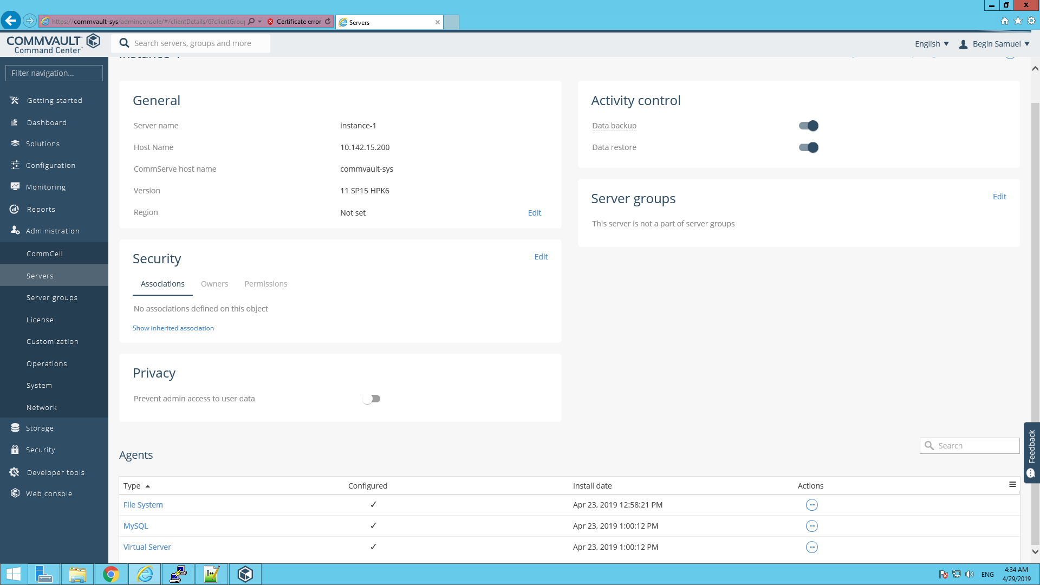

1. Under Agents, Click on “MySQL”. The list of instances under the agent “MySQL” will appear.

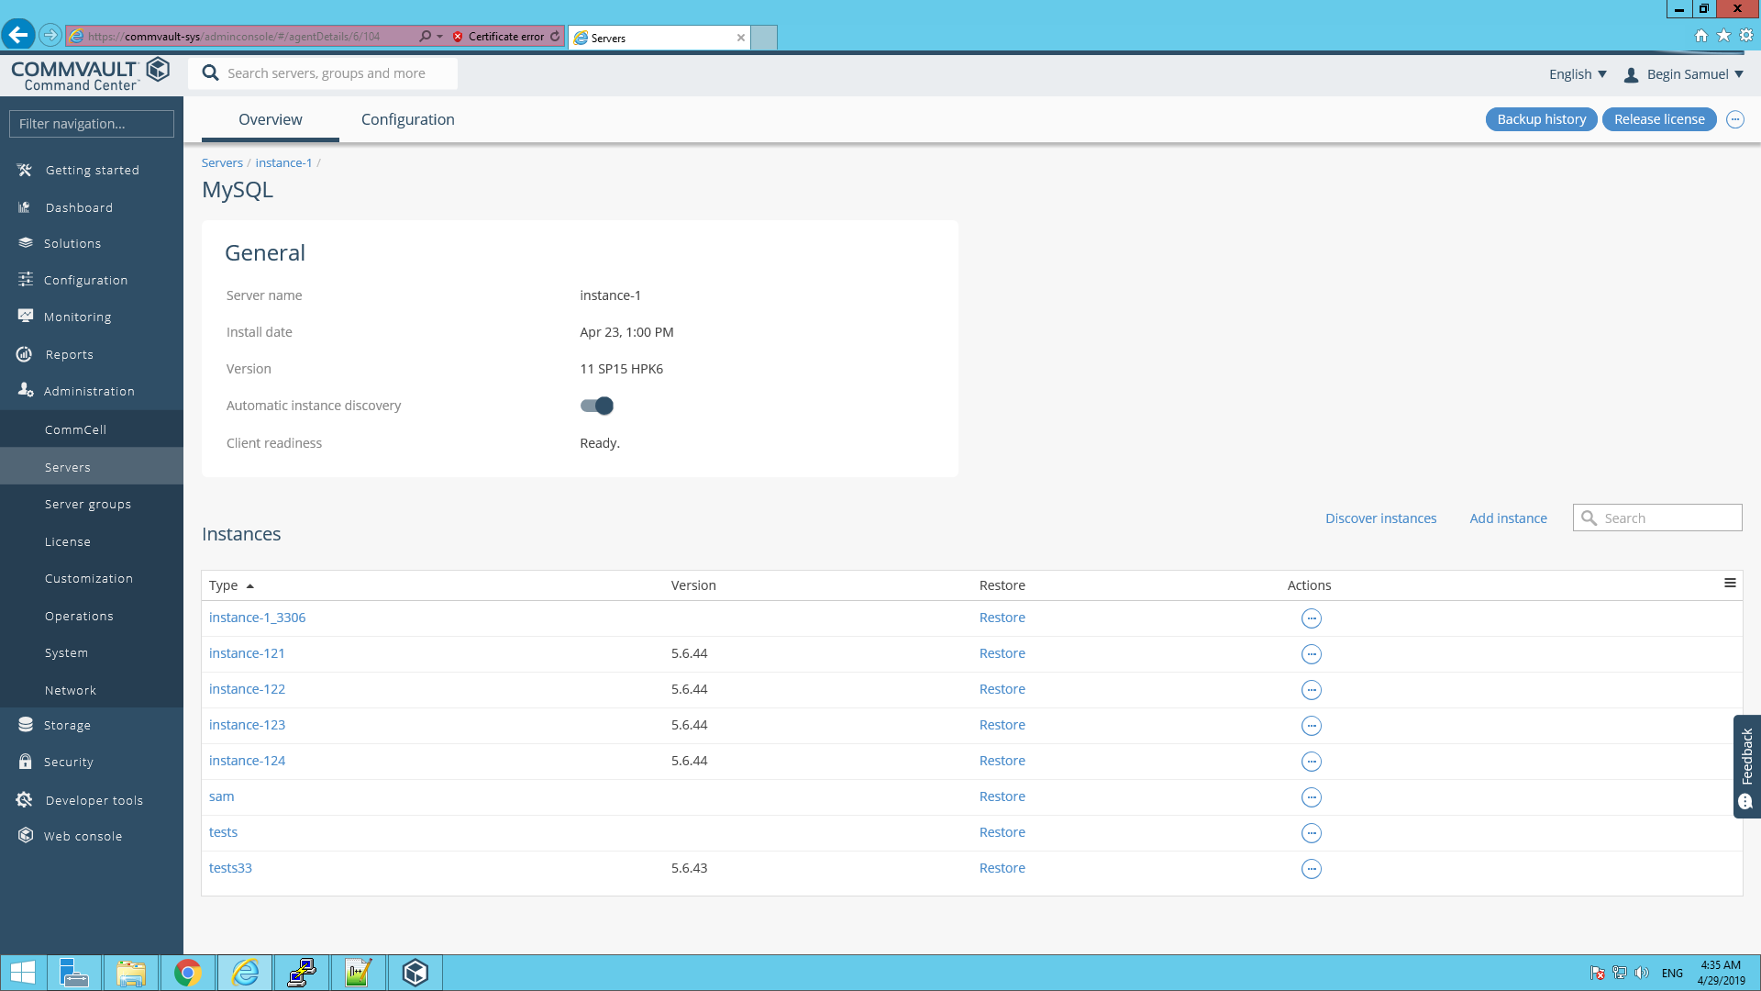

1. On the Instances page, Click on the “Add instance” option. Fill in the required fields, & select the plan to be used for adding instance. Click “Add” for adding the instance.

Socket file=/data/mysql/mysql.sock

Binary Directory="/usr/bin"

Log Directory="/var/log"

Configuration File="/etc/my.cnf"

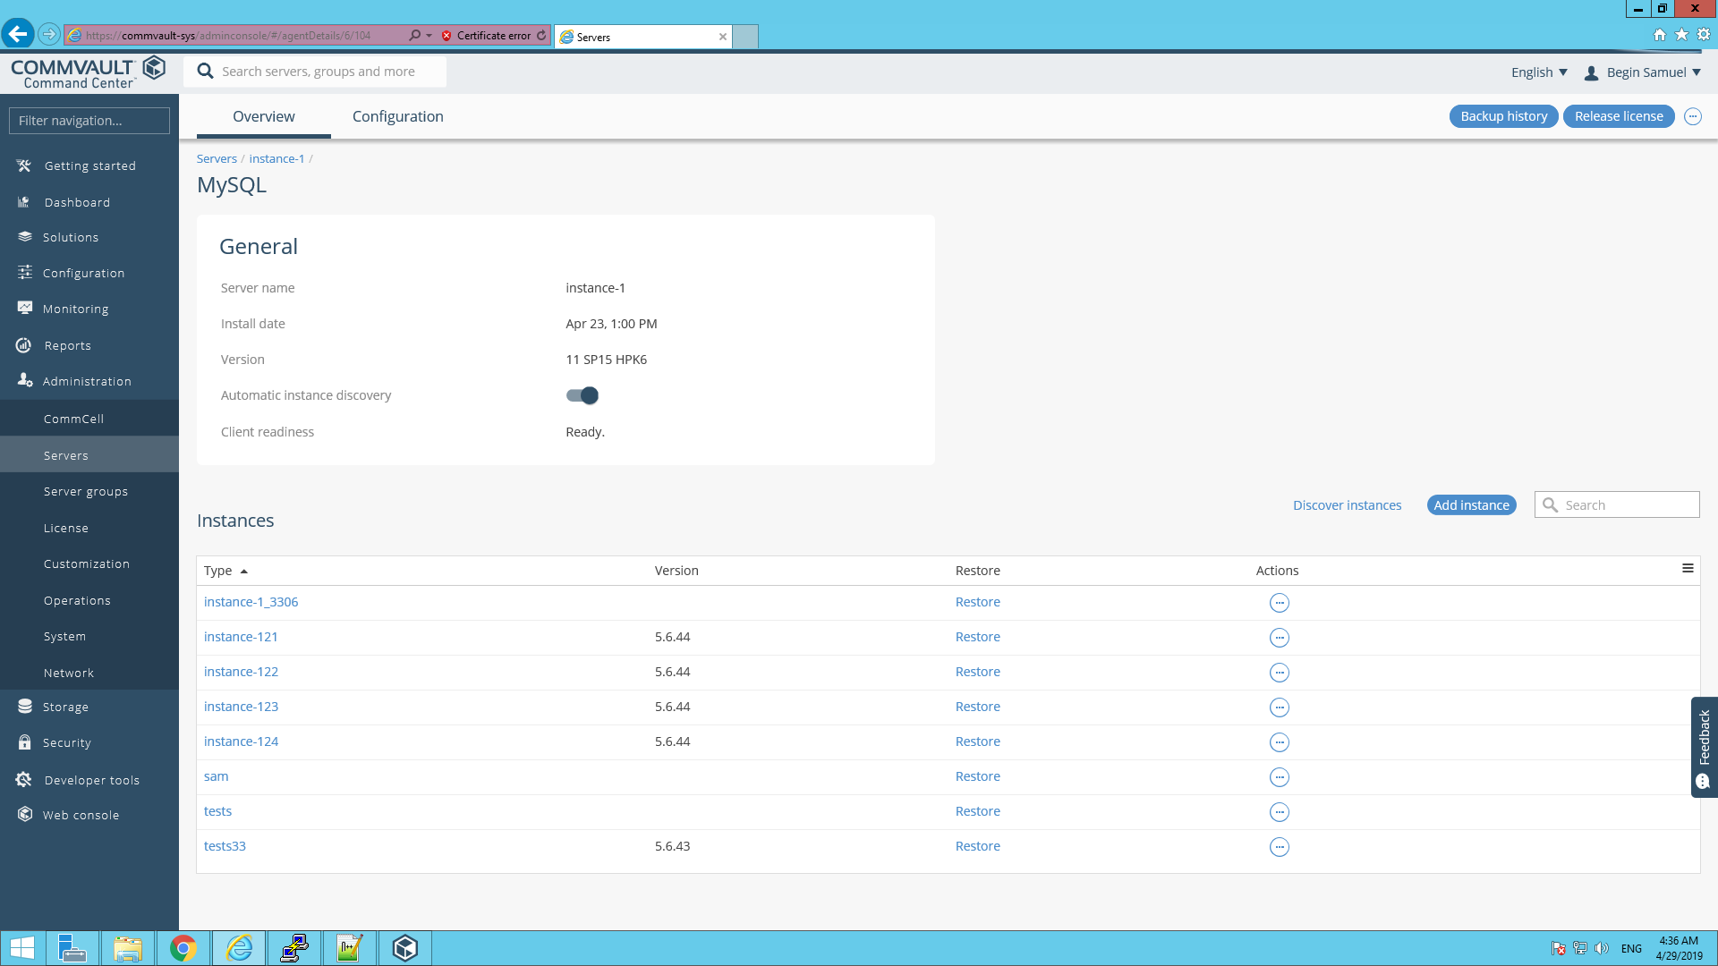

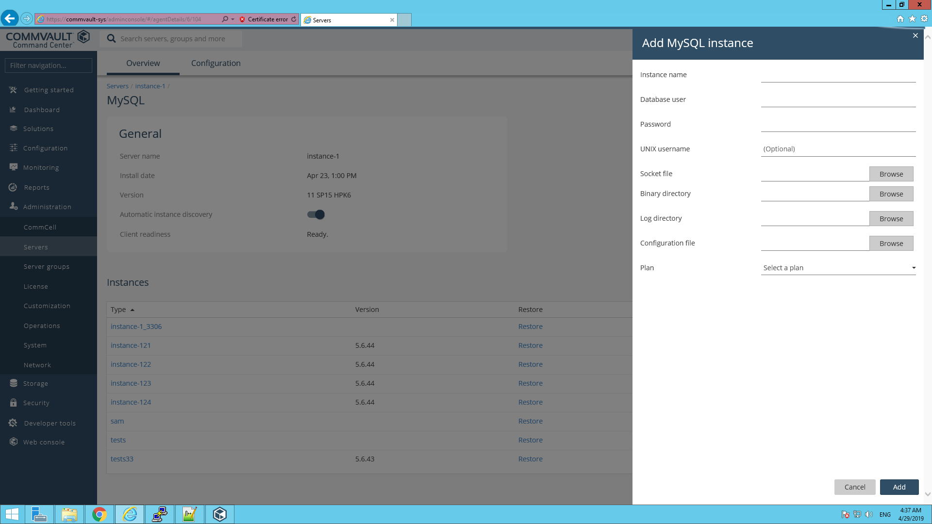

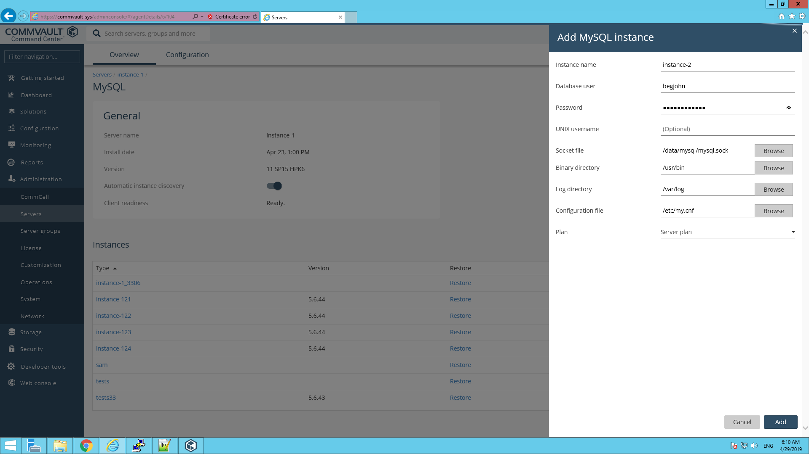

1. Select the added instance. Under the instance, Select the Database group.

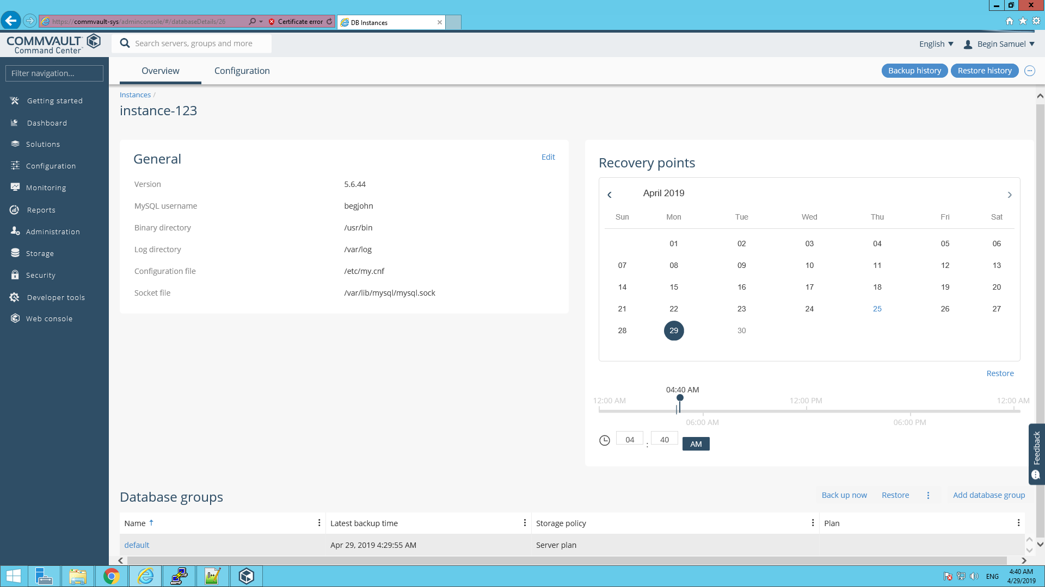

1. Under “Backup” tab, click “Back up now” available on the top right corner.

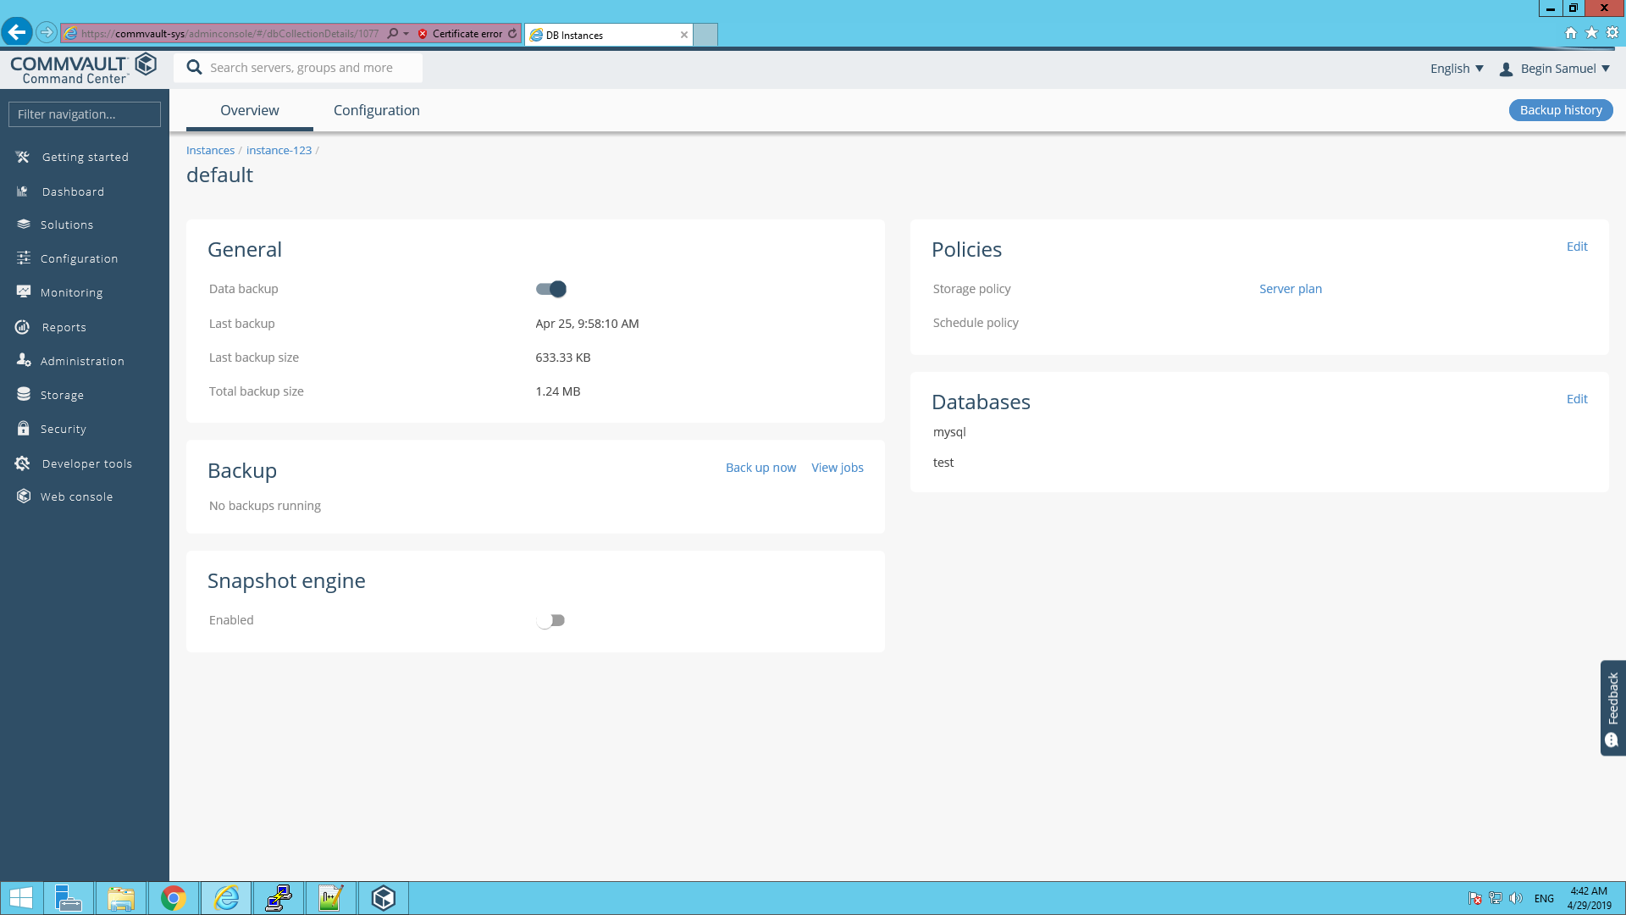

1. A tab asking backup level will appear. Select the desired backup level and click “OK”.

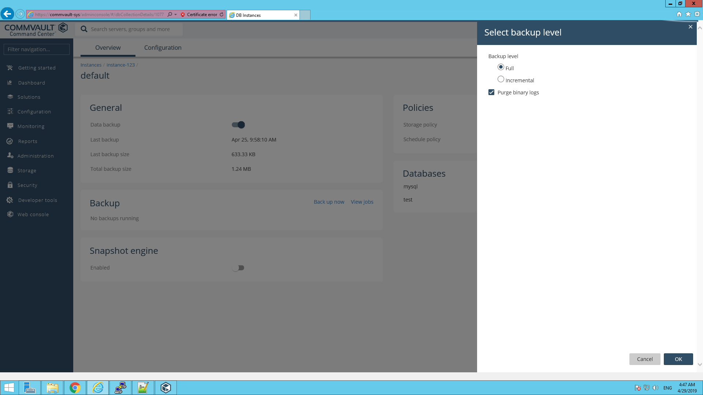

1. On the top right corner of the screen, you will find “Backup history”. Click on it to view the job history.

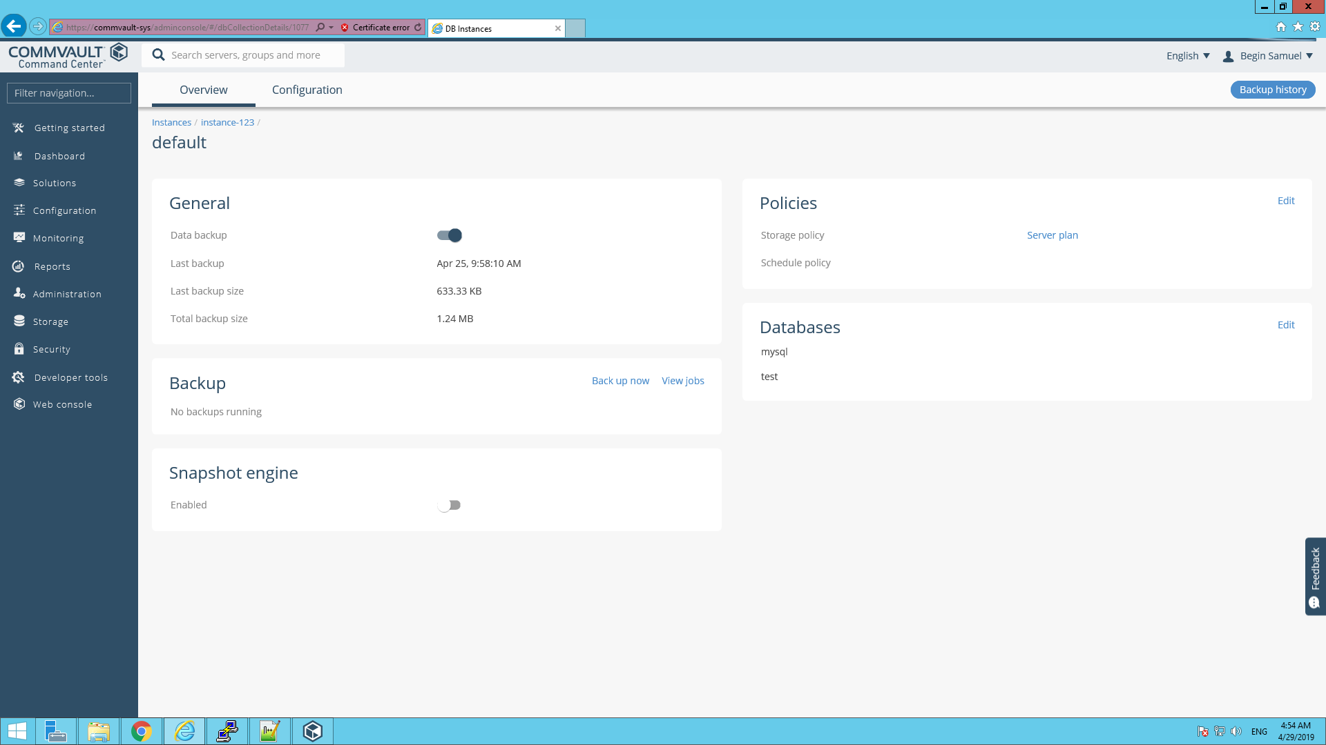

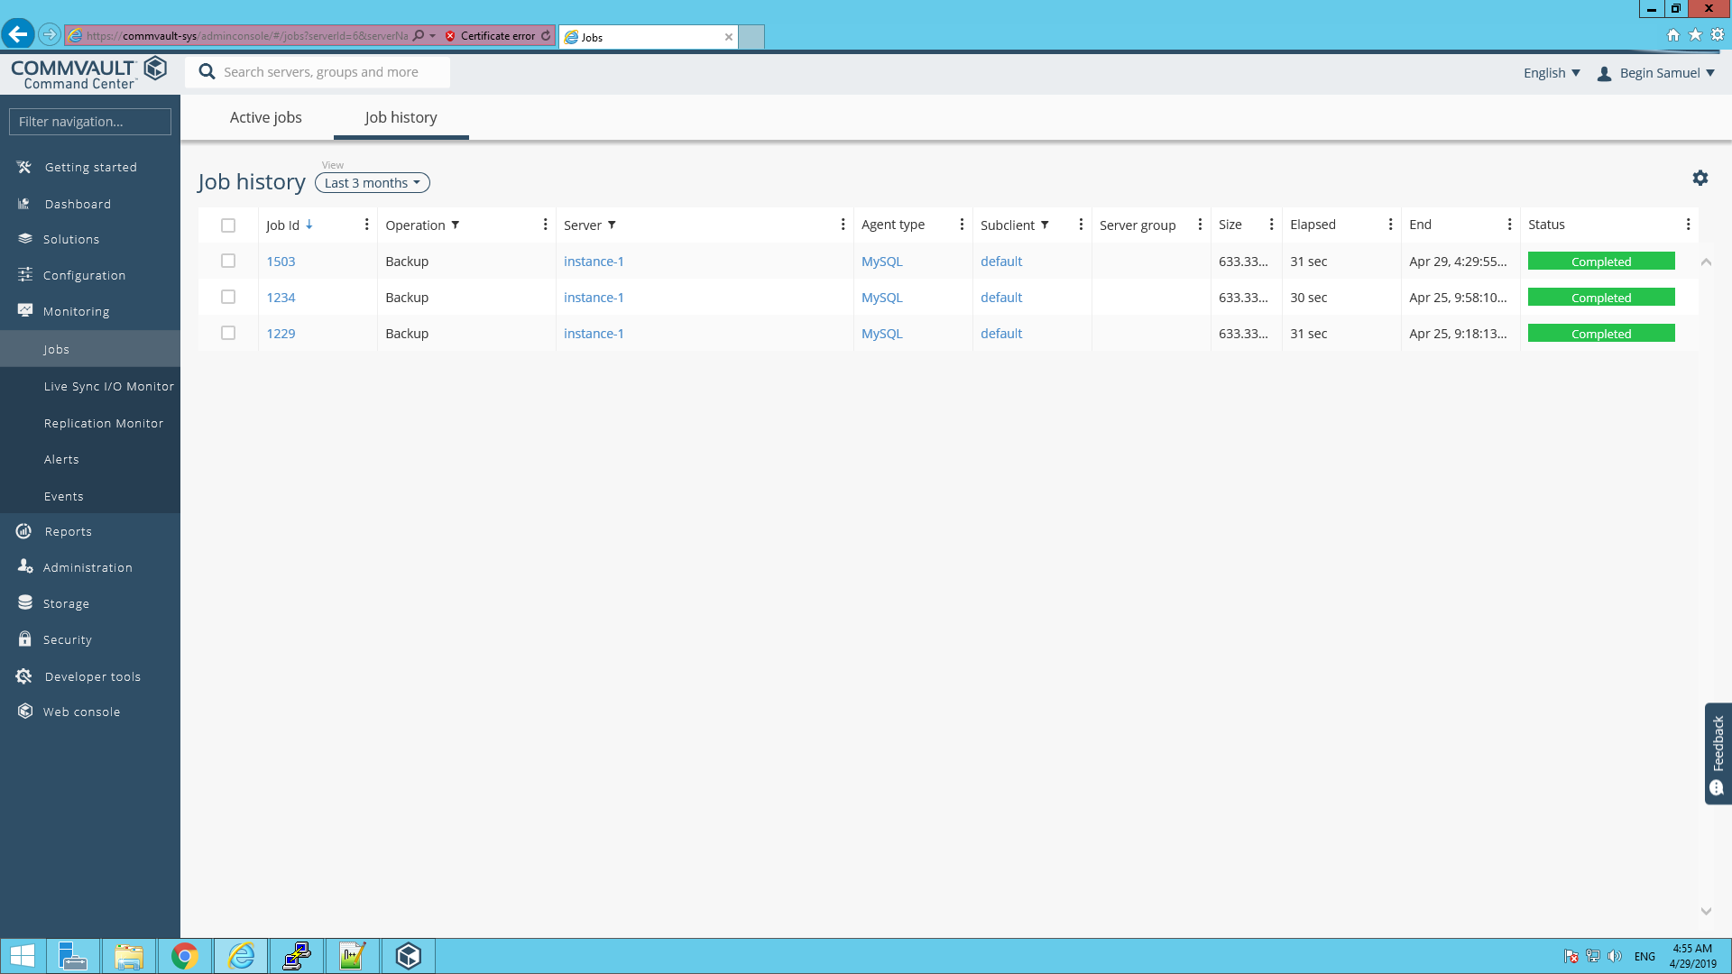

1. Once the backup is completed, the job id will be available in the job history. Select the job id. From the “job summary” tab, select “Restore” present at the top right corner of the tab.

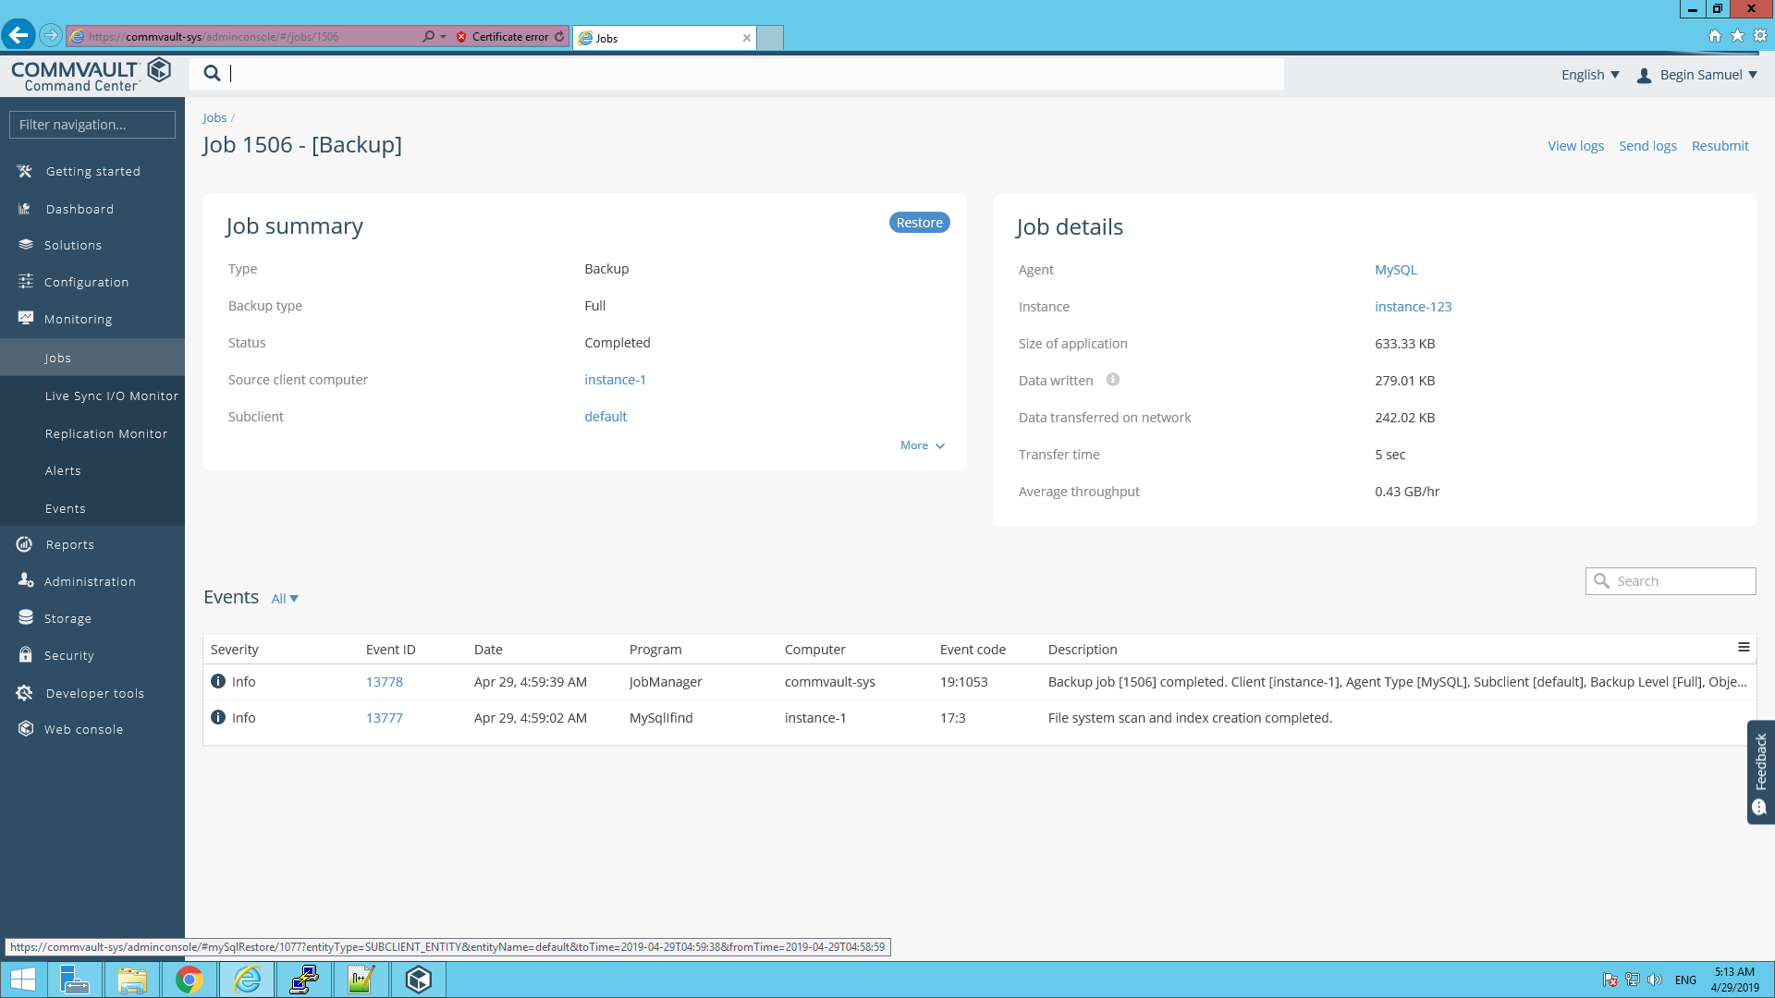

1. Then select the database(s) to restore.

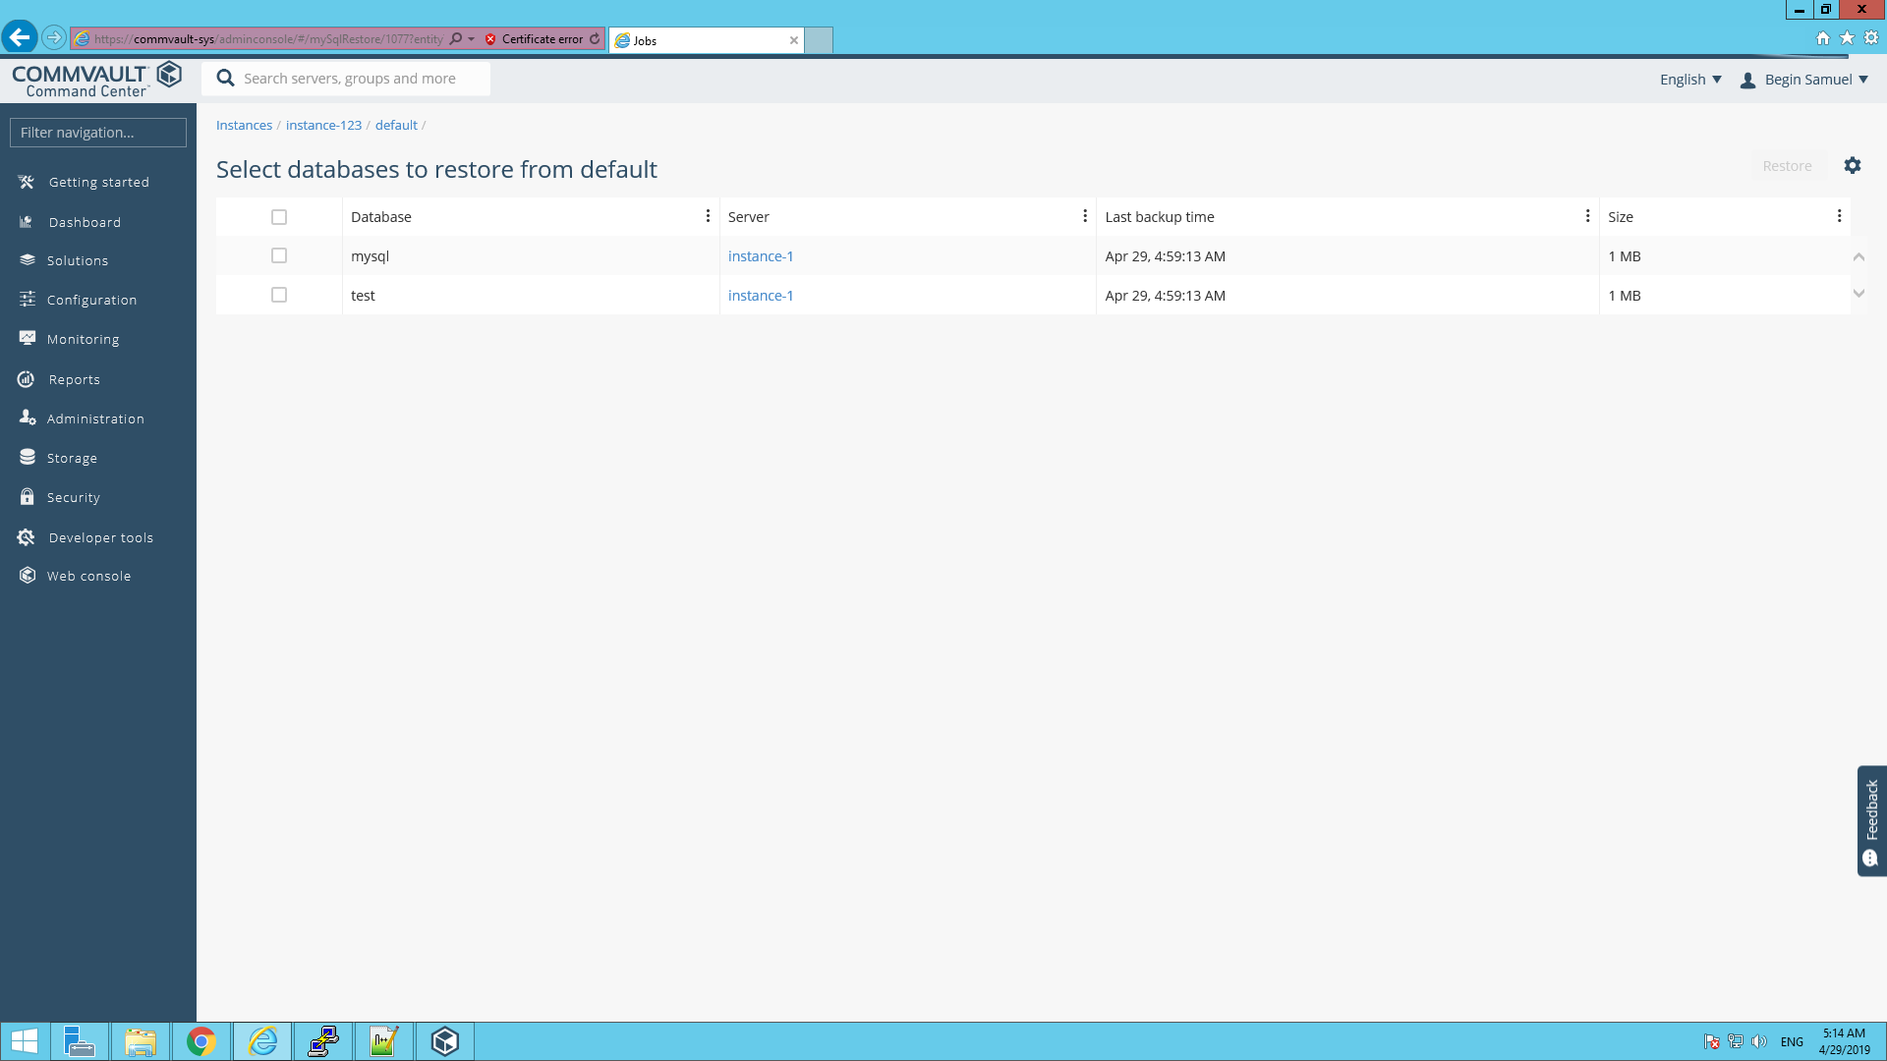

1. After selecting databases, Click “Restore” present on the top right corner of the page.

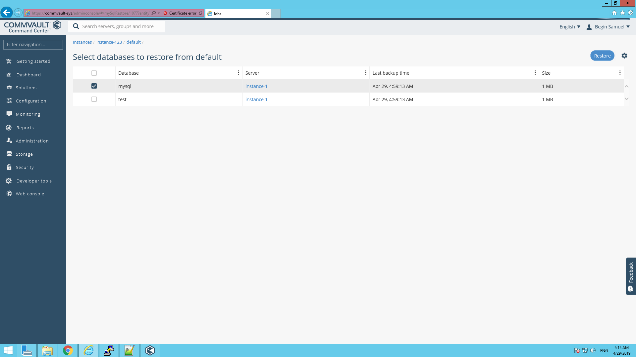

1. Select the Restore option and fill the required fields. Click “Submit”. Then confirm the restore by clicking “yes” in the pop-up.

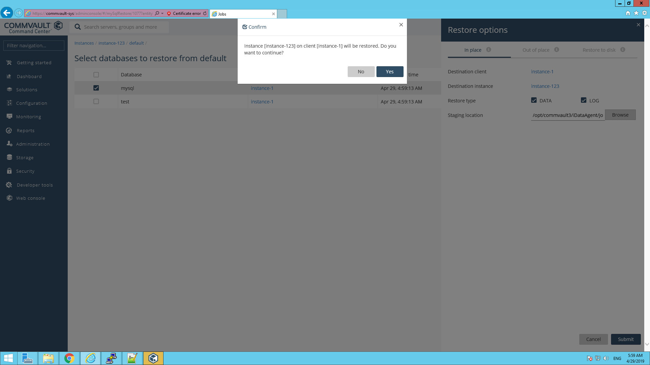

1. Navigate to “Monitoring->Jobs” to view the status of restore. Once the restore is completed, the job id will be available in the job history. Select the job id to view the log and restore job details.

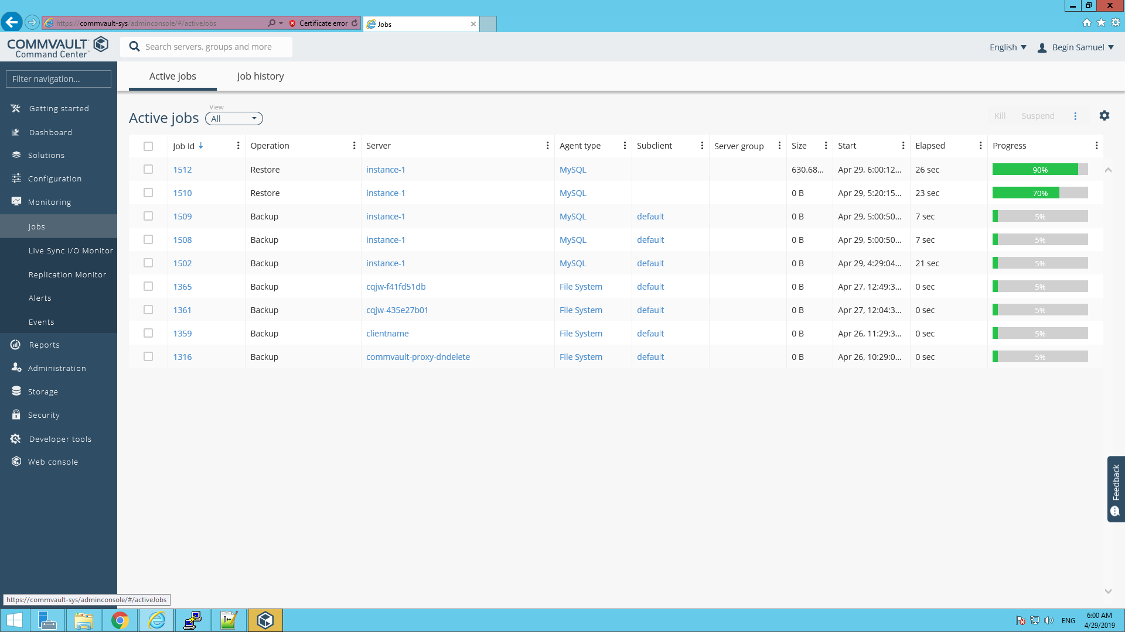

**Client installation**

1. To download the Linux agent to be installed on the linux client, Navigate to <https://cloud.commvault.com/webconsole/downloadcenter/dc.do> and provide commvault account credentials.

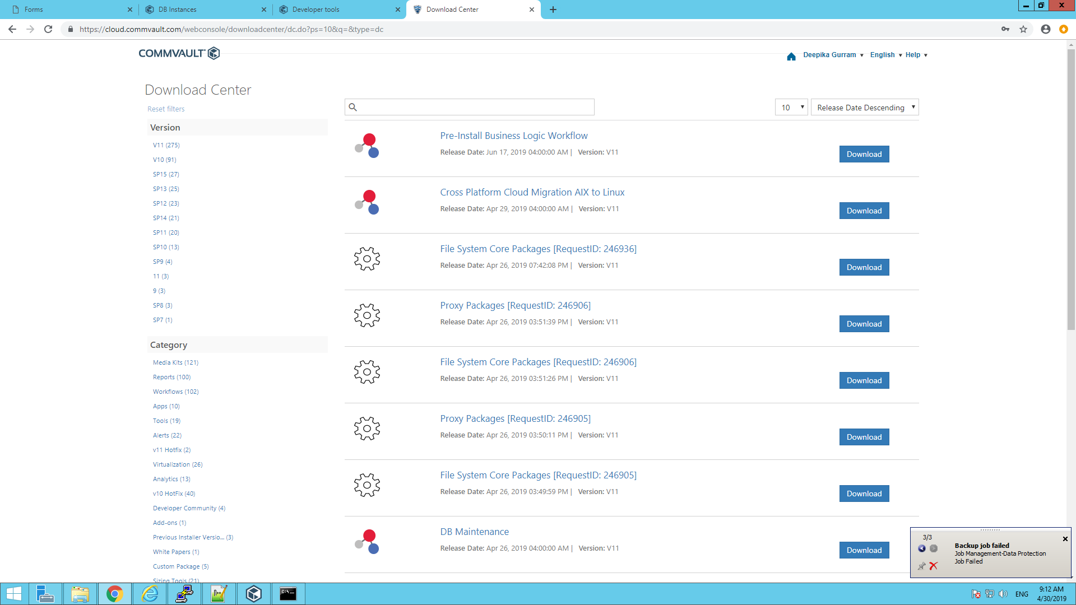

1. In the search tab, search for “Linux-x64”. A list of packages will appear. Select and download the package named “V11-SP15 linux agent”. “linux_pkg.tar” file will be downloaded.

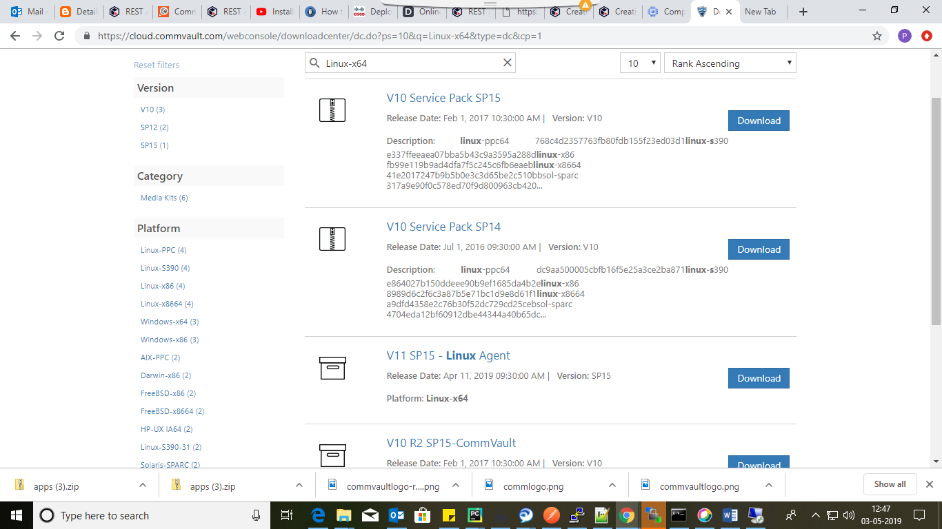

1. Upload the linux_pkg.tar file to a file repository. Fetch the available scripts for installing client and agent (namely install_client.sh & install_agent.py). For the scripts, Please refer the link https://wwwin-github.cisco.com/CloudCenterSuite/Content-Factory/blob/master/Backup/Commvault/README.md.
2. Place the available Sample answer file (default-final.xml) in the file repository. For the scripts, Please refer the link https://wwwin-github.cisco.com/CloudCenterSuite/Content-Factory/blob/master/Backup/Commvault/README.md.
3. The placeholders in the sample answer file will be replaced by actual value provided by user through CCM during deployment.